**CS551**

**ADVANCED SOFTWARE ENGINEERING**

**SPRING 2015**

**PROJECT TITLE: STUDENT ACCOMMODATION**

**SUBMITTED BY,**

**MANUSHA REDDY BETHELLI**

**SNEHA LAGANDULA**

**DHEERAJ REDDY BETHI**

**PROJECT GROUP: 11**

**ACKNOWLEDGEMENT**

The satisfaction and euphoria that accompanies the successful completion for any task would be incomplete without the mention of the people who made it possible and whose constant encouragement and guidance have been a source of inspiration throughout the course of the project work. We are grateful to have the opportunity of expressing our gratitude to all of them.

We wish to express our sincere gratitude to our course instructor, **Dr. Lee Yugyung**, Department of Computer Science for providing timely advice throughout the project. Her understanding, encouragement and personal guidance have provided the basis for the report.

We also thank our teaching assistants **Malathy Krishnan**, Mayanka Chandra Shekar, Bharath Viswanadham for their support and guidance throughout the project work.

Our special thanks to IBM Bluemix for providing the free cloud hosting service.

**INDEX**

1. Deployment
2. User Manual
3. Project management
4. Project proposal
5. Project plan
6. Increment 1
7. Increment 2
8. Increment 3
9. Increment 4
10. Presentation material
11. Implementation package
12. URL
13. **DEPLOYMENT:**

**Source Code:**

**Project Code:**

1. **USER MANUAL:**

**Introduction:**

In the world of modern technology where the internet market has seen a revolution, Internet has been an epicenter for it. About 70% of the students’ population use Internet. The project “Student Accommodation” web Application uses simple and effective design to help students find accommodations anywhere near their universities on the move. This application is given access to all the students in the university using their students ID’s as a primary key. This application needs internet connection to search for places near the University for an Accommodation. All the places with vacancies near the university can be found along with a route map from the university to the desired location in search. The aim of this project is to help students find the accommodation that most suited to their needs as easily and as quickly as possible. We realize how essential it is to find the right student accommodation for a proper and decent academic lif**e.**

**How to use the System?**

The application “Student Accommodation” is compatible to on different browsers such as Mozilla, Internet Explorer, Crome. This application can be launched using Web Matrix. This application is to provide students with proper information about the available and convenient vacancies for accommodation. Also, provides the students with contact information about the available vacancies. Initially, a login registration form is granted. Students who wants to use the application can register. With the registration process, the student creates user name and password. These credentials are further used to login to the application. After a log in, students are provided with various features to search for the accommodation. Various search fields are provided with specific information such as ZIP code of the location, number of rooms required, preferred distance etc. The search result would be a list of vacancies that are available with in a specific location .Also, students are provided with additional information such as contact information, routing map from their current location to their desired location.

**Error Recognition and Handling:**

The user is expected to provide valid information for registration of the system. User has to provide valid credentials to login to the system. User should send an email to the administrator by entering email address in a valid format.

**Sample Interaction: Scenario 1**

When the user gives details in the search field, a list of vacancies that are currently available at that particular location should be displayed.

The following screenshot illustrates how the user searches for vacancies by giving certain details.

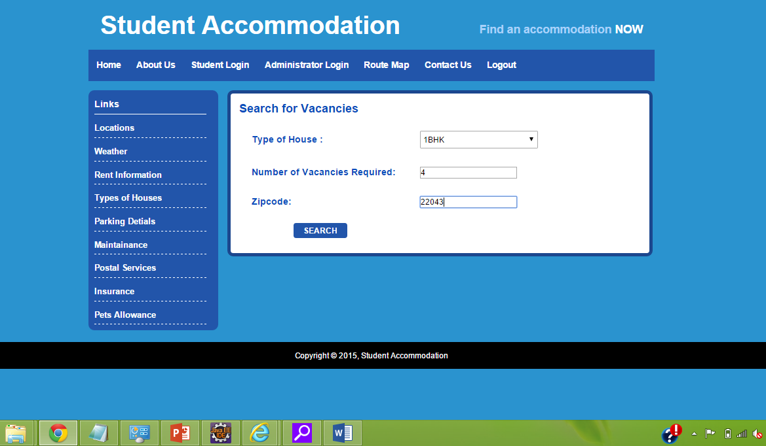

As a result, the system displays all the vancacies that are currently available at that particular location.

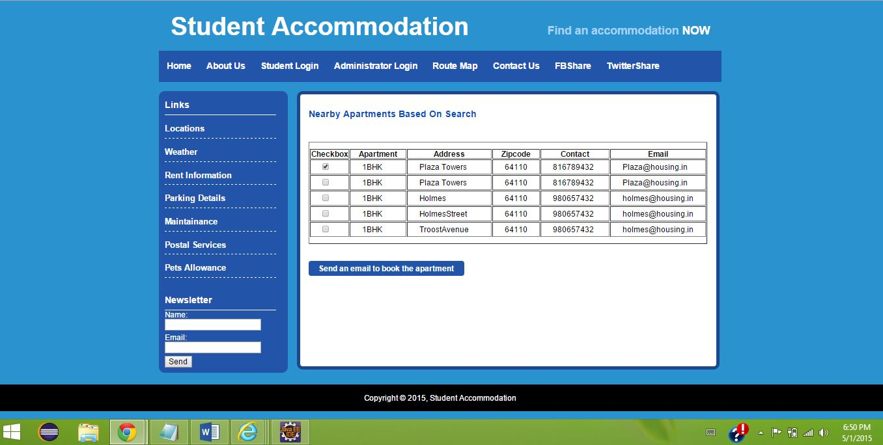

**Sample Interaction: Scenario 2**

When the administrator enters all the details about a newly available vacancies, all the entered details should be stored in to the database and are retrieved when required.

The following illustrates how the administrator provides details about all the newly available vacancies of a particular location.

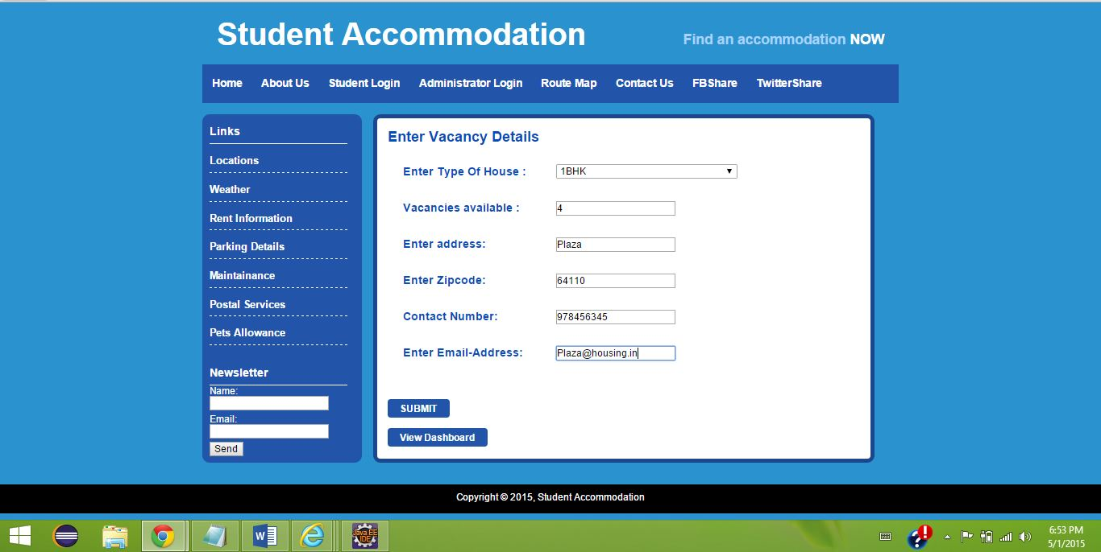

As a result, the system stores all the provided details about a particular vacancy in to the database.

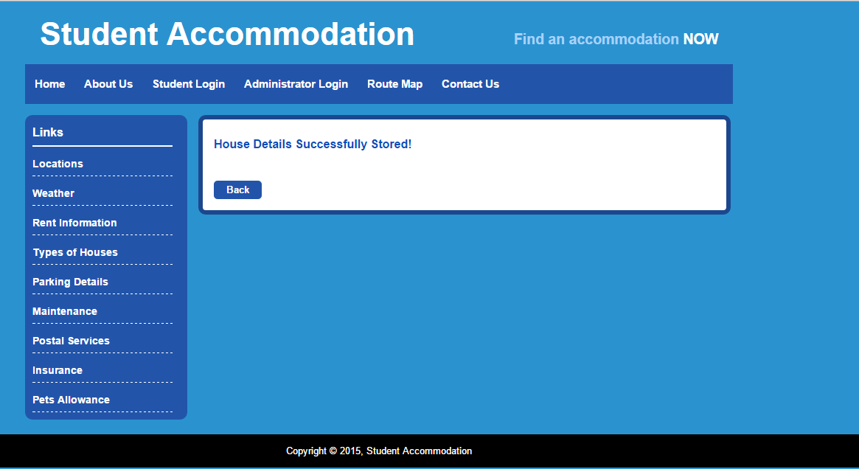

**Bugs and Deficiencies:**

* When the user enters his phone number while registering to the application, the number that he enters should be not less than or no greater than 10 digits. However, in our application, the system accepts phone number that is less or greater than 10 digits. This is considered to be a bug and proper validations are to be provided to the system.
* When the user log out of the application, the page is redirecting to the home page instead of redirecting to the new login page.
* The SMTP protocol that is used for newsletter subscription is has poor performance. Not all the time the email is sent to the respective email address.

1. **PROJECT MANAGEMENT**
   1. **Project Management Report:**

**Summary:**

In our software development, for planning of our project, we used agile methodology. We divided the project into four iteration with each iteration having few requirements to work on. In each iteration, we divided the task among team members. Scrum Do was the software we used for the planning of our project. At each iteration task were assigned to all the member of the project giving duration for each task. In each increment, all the members have worked from development of the application from front end to the back end. We as a team worked collaboratively to rectify the problem that are raised in each iteration.

The below are the tasks that were scheduled for each increments:

**Increment 1:**

UI Implementation with validations (Manusha Reddy)

Database connection and Documentation (Sneha Lagandula)

CSS (Dheeraj Reddy Bethi)

**ScrumDoLink:** <https://www.scrumdo.com/projects/project/student_accommodation/iteration/122907/board>

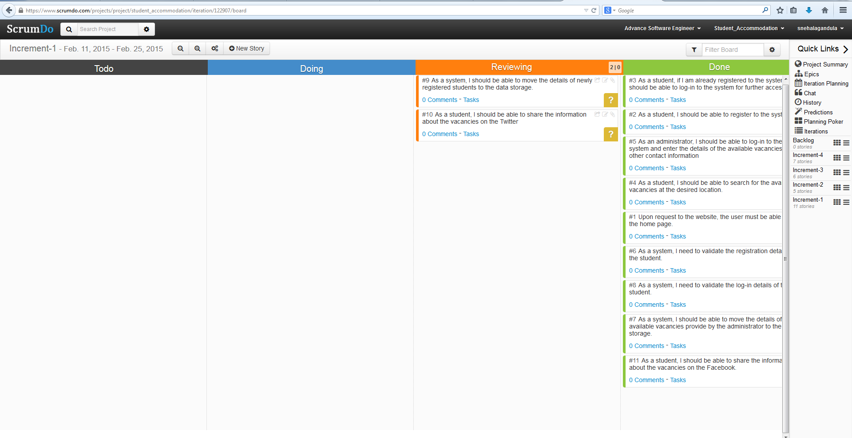

**Increment 2:**

Database storage and retrieval (Manusha Reddy)

Database storage, validations, testing the login validations (Sneha Lagandula)

Html validations (Dheeraj Reddy Bethi)

**Scrum Do Link:**

[**https://www.scrumdo.com/projects/project/student_accommodation/iteration/122911/board**](https://www.scrumdo.com/projects/project/student_accommodation/iteration/122911/board)

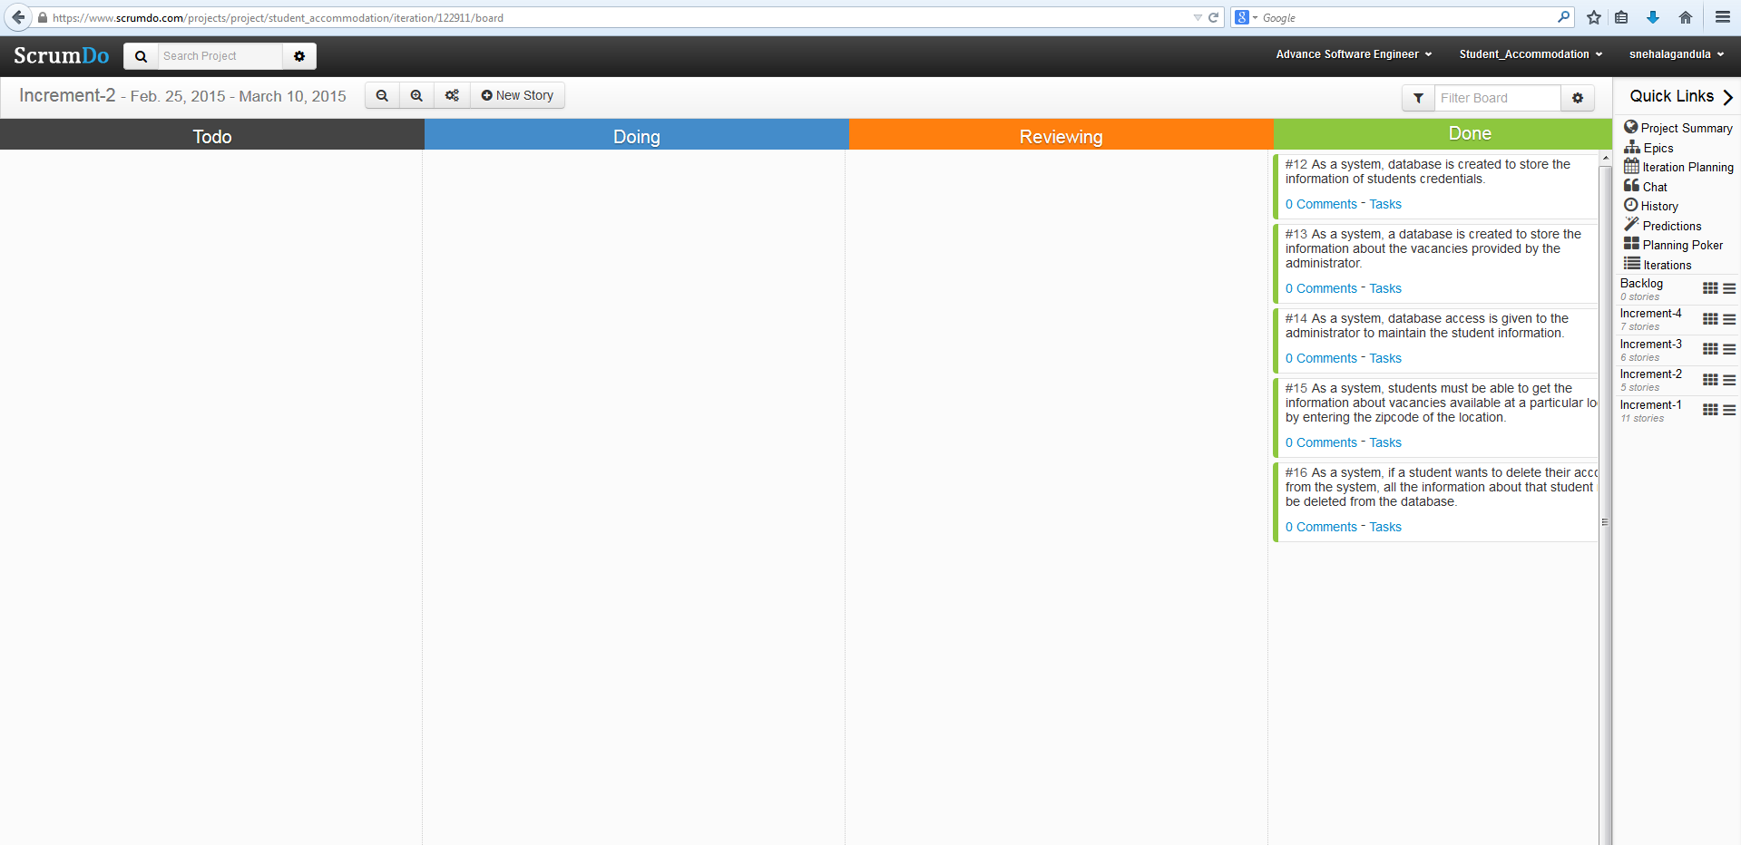

**Increment 3:**

Implementation of Google Maps API and Distance Matrix Algorithm (Manusha Reddy Bethelli)

Bootstrap framework for User Interface, integration of UI with back end (Sneha Lagnadula)

Validations (Dheeraj Reddy Bethi)

**Scrum Do Link**:

<https://www.scrumdo.com/projects/project/student_accommodation/iteration/122919/board>

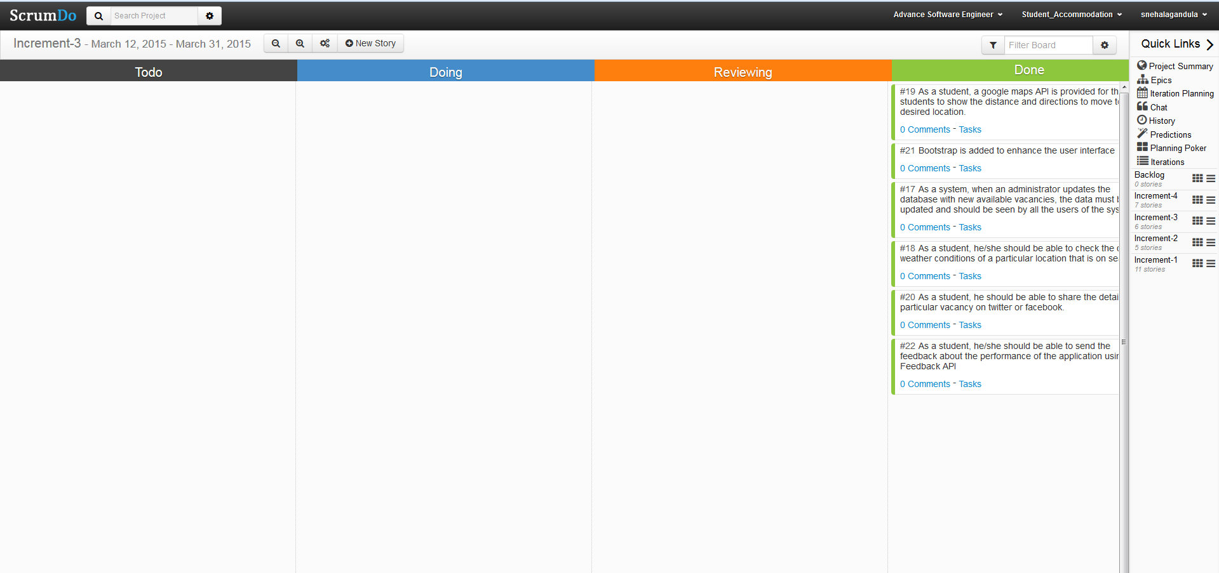

**Increment 4:**

Web Service and Integration (Manusha Reddy Bethelli)

External API call and News Letter Feature (Sneha Lagandula)

Front end testing (Dheeraj Reddy Bethi)

**Scrum Do Link:** <https://www.scrumdo.com/projects/project/student_accommodation/iteration/122921/board>

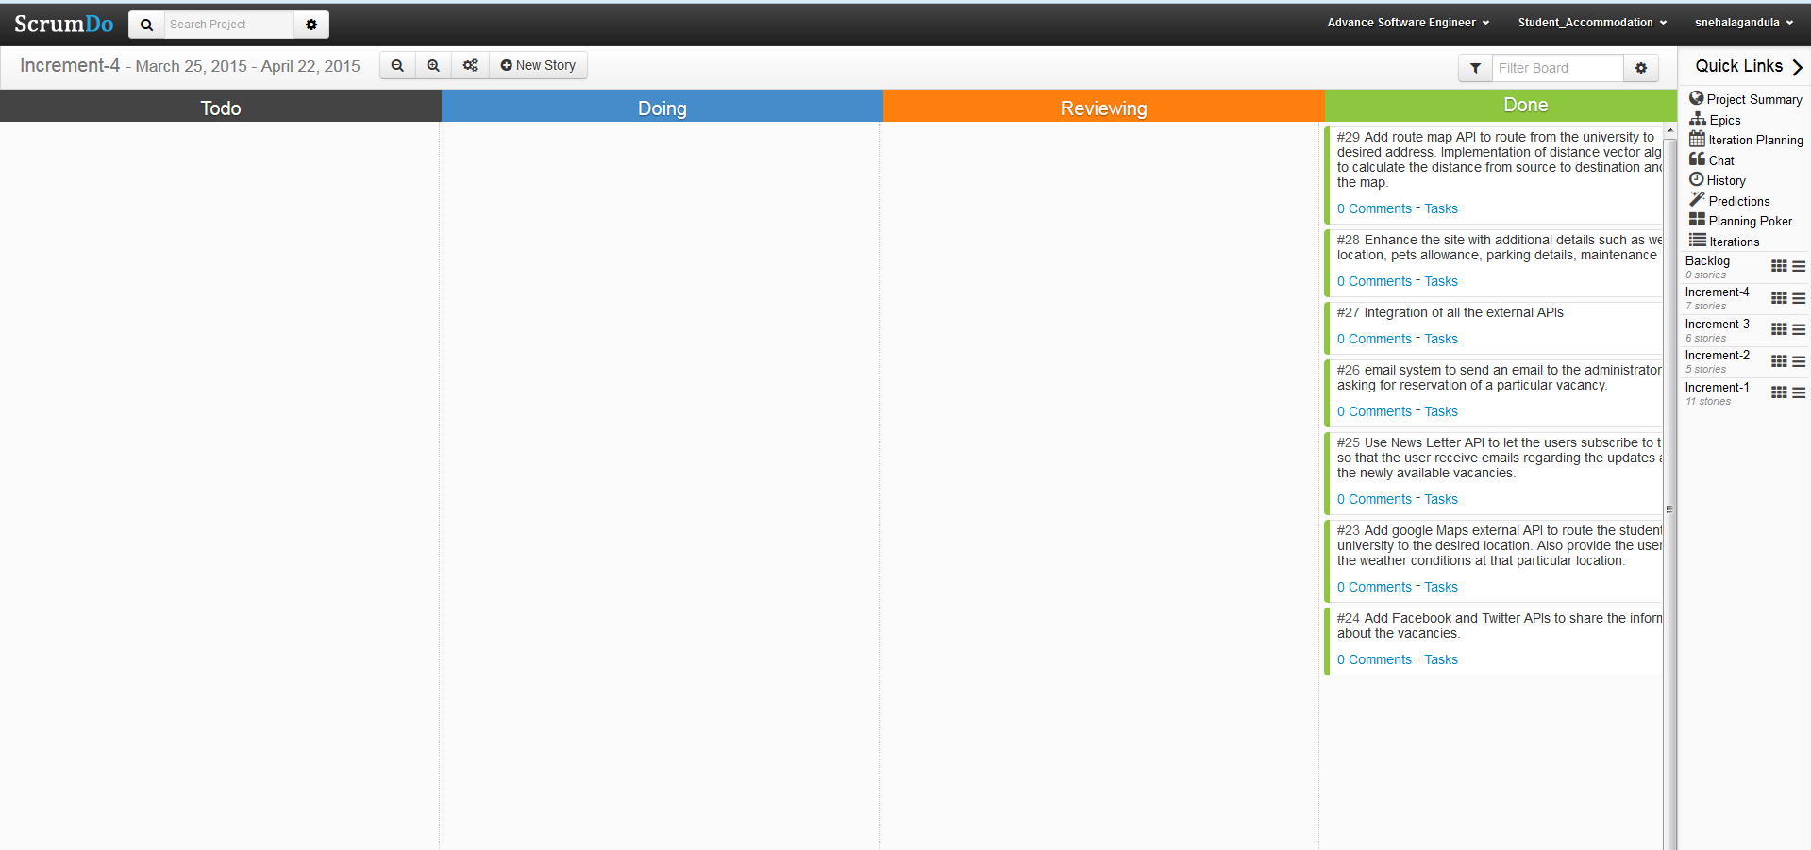

* 1. **Final Project Evaluation:**

According to our need to develop software application, we used agile methodology. We used agile methodology because in some way, the project we develop will be iterative and incremental. At each increment, the software is more refined and increased with its features. Our project Student Accommodation application is developed in four increments with each increment having few requirements that is developed as an entire flow from front end to back end. Scrum Do is being used for our project management. We used it for maintaining the artifacts of our project.

We are team of three in our project. We have shared the tasks equally for each increment. And at the end of increment, we integrated the tasks to make the desired result. We, the team members have worked on the project from the idea to the implementation. Using agile process helped us to certain extent in developing the software in each increment and resolving issues in the further increment. However, it was difficult for us to estimate the amount of effort required for each increment in software development cycle. Further in future, agile method can be used effectively by adapting changes to different circumstances, by effectively communicating with project team members about the requirements in each increment. Problems can be nullified by handling tasks, quality control, and detail management of the project. Though we stick to the project plan schedule consistently, we have had problems such as time constraints, setting up goals for a certain task. Learning the required tools and working on the project parallel was the difficult task for us as time was one of the factors to work on the project. We as a team have learnt how to organize the requirements of the project in an effective and orderly manner. We learnt different strategies to work on a given task within the given time. Using agile method helped us understand where we stand in the development phase as per the defined requirements. Working on this project helped us grow in the ability as a software developer. Specifically, it taught the principles of effective project management.

1. **PROJECT PROPOSAL**

**Motivation:**

In the world of modern technology where the internet has seen a revolution, Web applications has been an epicenter for it. About 70% of the students’ population use Internet. The project “Student Accommodation” web Application uses simple and effective design to help students find accommodations anywhere near their universities on the move. This application is given access to all the students in the university using their students ID’s as a primary key. This application needs internet connection to search for places near the University for an Accommodation. All the places with vacancies near the university can be found in search.

**Significance:**

A lot of international students face the problem of finding a temporary or permanent accommodation at the very moment they reach university for a long stay. Hence, to resolve this problem, we came up with an idea to develop an application that help students find a place to live either with temporary or permanent accommodation.

**Objective:**

The whole objective of this application is to provide students with proper information about the available and convenient vacancies for accommodation. Also, provides the students with contact information about the available vacancies. Initially, a login registration form is granted. Students who wants to use the application can register the application. The moment students register for the application, they are provided with a username and password. These credentials are further used to login to the application. After a log in, students are provided with search fields where they can provide specific information such as ZIP code of the location, number of rooms required, preferred distance etc. As a result, all the vacancies available within a specific location is shown. Also, users are provided with additional information such as contact information, routing map from their current location to their desired location.

**Technologies and System Features:**

* Operating Systems: Windows, Ubuntu
* RAM: 2GB or more
* Technical Requirements: Eclipse IDE, MySQL Database, Bootstrap Framework, HTML5, Java, JGraphs

1. **PROJECT PLAN**
2. **Introduction**

In the world of modern technology where the mobile market has seen a revolution, Internet has been an epicenter for it. About 70% of the students’ population use web applications. The project “Student Accommodation” web Application uses simple and effective design to help students find accommodations anywhere near their universities on the move. This application is given access to all the students in the university using their students ID’s as a primary key. This application needs internet connection to search for places near the University for an Accommodation. All the places with vacancies near the university can be found in search.

**2. Project Goals and Objective**

**a. Specific objectives**

The whole objective of this application is to provide students with proper information about the available and convenient vacancies for accommodation. Also, provides the students with contact information about the available vacancies. Initially, a login registration form is granted. Students who wants to use the application can register the application. The moment students register for the application, they are provided with a username and password. These credentials are further used to login to the application. After a log in, students are provided with search fields where they can provide specific information such as ZIP code of the location, number of rooms required, preferred distance etc. As a result, all the vacancies available within a specific location is shown. Also, users are provided with additional information such as contact information, routing map from their current location to their desired location.

**b. Significance**

A lot of international students face the problem of finding a temporary or permanent accommodation at the very moment they reach university for a long stay. Hence, to resolve this problem, we came up with an idea to develop an application that help students find a place to live either with temporary or permanent accommodation.

**3. Project Background**

We students came up with this idea to help most of the international students in finding available vacancies for their accommodation. We have not found any application related to the “Student Accommodation” android application.

4. **Proposed System**

**A. Requirement Specification**

• **Functional Requirements**

• When a student registers for the first time he/she will be given a username and password to access the application.

• Students can search for the available vacancies at their desired locations.

• Up on the entered location, students are shown a map with all the available vacancies near that location.

• Students are provided with specific details such as contact information of the houses which are near to the university, routing map from the student’s current location to their desired location.

• Administrator has an access to portal to update the database with available vacancies at a particular location.

• **Non-Functional Requirements**

• Users have access to the application all the time

• It gives high security by providing access only to university students

* As the database is limited to locations that are close to the university, the retrieval of information is fast.

• Provides limited accessibility by giving access only to authorized

Students.

• **Technical Requirements**

• User Interface: HTML, CSS, JavaScript, Java Applets

• Back End: Java, SQL server 2014

• Architectural Design using Microsoft Visio 2013, Visual Paradigm

**Workflow Analysis**

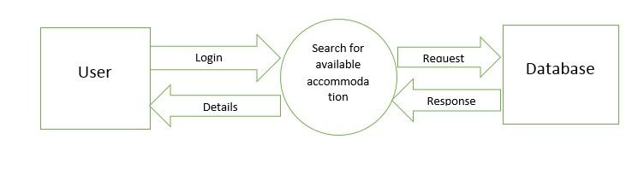

**Technological and Architectural Requirements**

• Android Studio

• SQLite

• Google Maps API, Google Places API

**b. Framework Specification: Build an overall system model**

• **Assumption and Principles**

• To build a database with all UMKC Student IDs is complex, we assume it to be limited.

• We assume our local database to be our centralized database

• **Methodologies**

• Agile Software Developmen

**System Architecture Diagram**

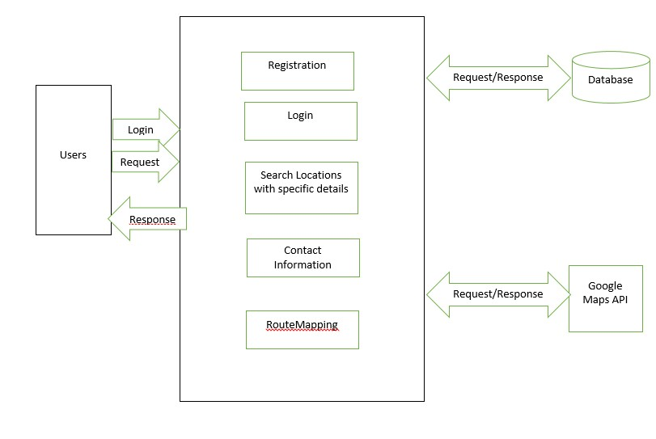

**c) System Specification: Identify Primary Services**

**Existing Services: Name, Description URL**

Name: Geo Location.

URL: https://developers.google.com/maps/documentation/business/geolocation/

Name: Direction Service

URL: https://developers.google.com/maps/documentation/directions/

**Class Diagram**

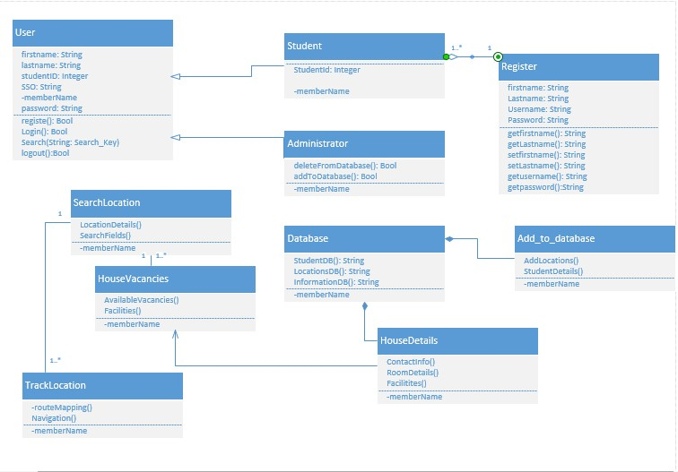

**Sequence Diagram:**

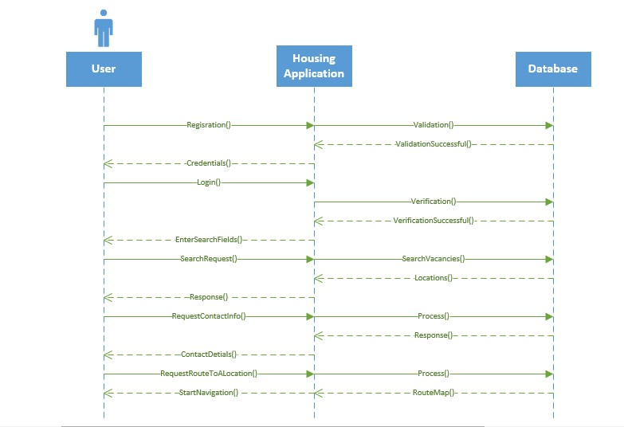

**5. Plan by Service (Scrum Do)- include screenshots to your report**

**a. Schedule for the four different increments**

**User Stories**

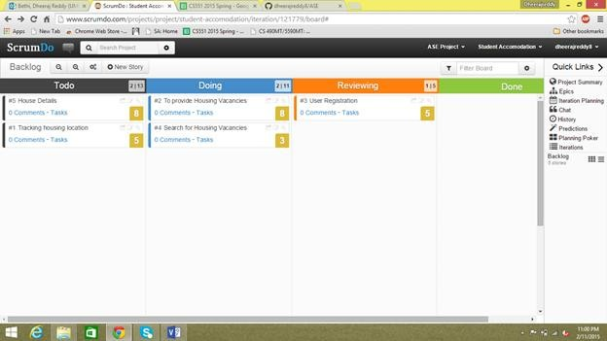

**1) First Increment**

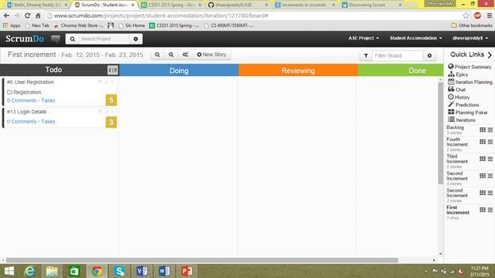

**2) Second Increment**

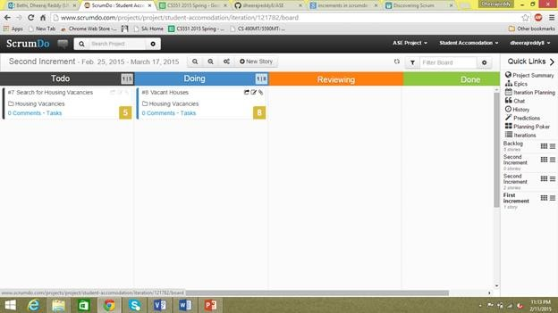

**3) Third Increment**

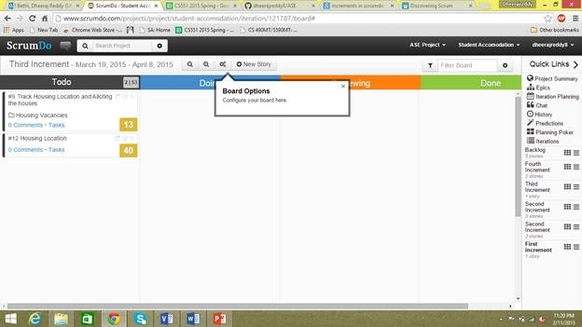

**4) Fourth Increment**

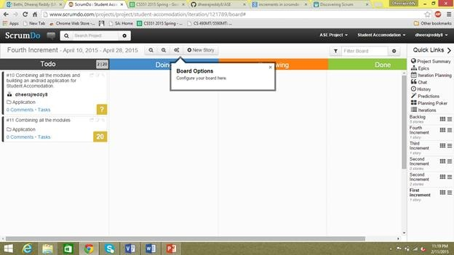

**Risk Management**

**Technological and Architectural Requirements**

• The user must have a smart phone.

• GPS must be turned on to get real time data and to send the current location in case of emergency

• It is compatible with all the Android phone

**Bibliography:**

<https://play.google.com/store/apps?hl=en> <https://www.google.com/maps> <https://www.google.com/maps/d/viewer?&mid=zBrq7C8N4BEM.k5H-MWQcyEec>

1. **INCREMENT 1:**

**IMPORT EXISTING SERVICES:**

In the first increment, user interface for log-in form, registration form with validations has been created for student and administrator access. Hence, no existing web services are used so far in the first increment.

However, for the further increments, we are to implement the following APIs:

User Feedback API: [http://api.sandbox.freelancer.com/User/getUserFeedback.{xml|json}](http://api.sandbox.freelancer.com/User/getUserFeedback.%7bxml%7Cjson%7d) Geo Location API: <https://developers.google.com/maps/documentation/business/geolocation/> Direction Service API: <https://developers.google.com/maps/documentation/directions/> Facebook API: <https://facebook.com/share/>

Twitter API: <https://twitter.com/share/>

Source code for the so far developed application is uploaded in the GitHub.

**DETAIL DESIGN OF SERVICES:**

•**User Stories for first increment**

The first increment includes development of log-in form and registration form for students and administrators with validations. The student details provided in the registration form will be stored in a database for further access. The log-in details of a student will be validated to avoid unauthorized access to the system

• **Design of Mobile Client Interface:**



**Sequence Diagram**

A sequence diagram is an interaction diagram that provides the collaboration of objects depending on a particular time sequence. The following is the sequence diagram that shows the flow of processes that operates one after the other in a certain order. The sequence diagram is to show the flow of student registration and login form with certain validations.

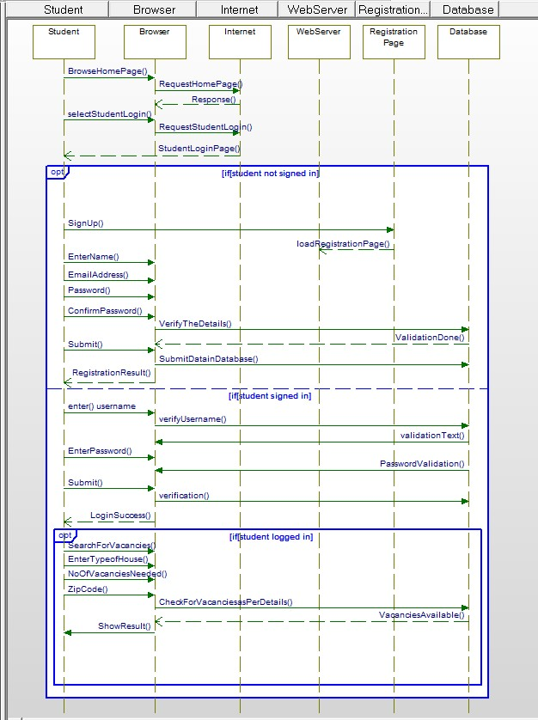

**Sequence Diagram for AdminLogin:**

The following sequence diagram explains the log-in action of the administrator. It shows the flow with which administrator can store the details about the vacancies available at a particular location.

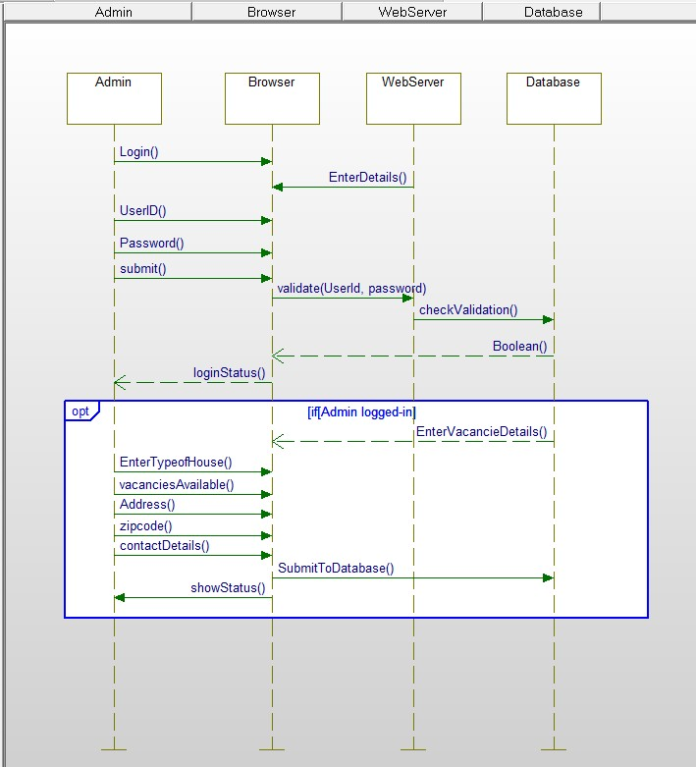

**• Class Diagram**

A class diagram identifies the structure of the application by describing the relationship between the objects and classes of the system.

The following class diagram describes a student or an administrator log-in to the website.

The system has two types of users, student user and the administrator. The student logs-in to the account only if the student is already registered in to the system. The student or admin logs-in to the system by entering the username and password, the system then validates the provided log-in details, and if successful, the system connects the user to the account for further access. If not successful, the system allows repeated attempts to the user and prevents the entry until the log-in is successful.

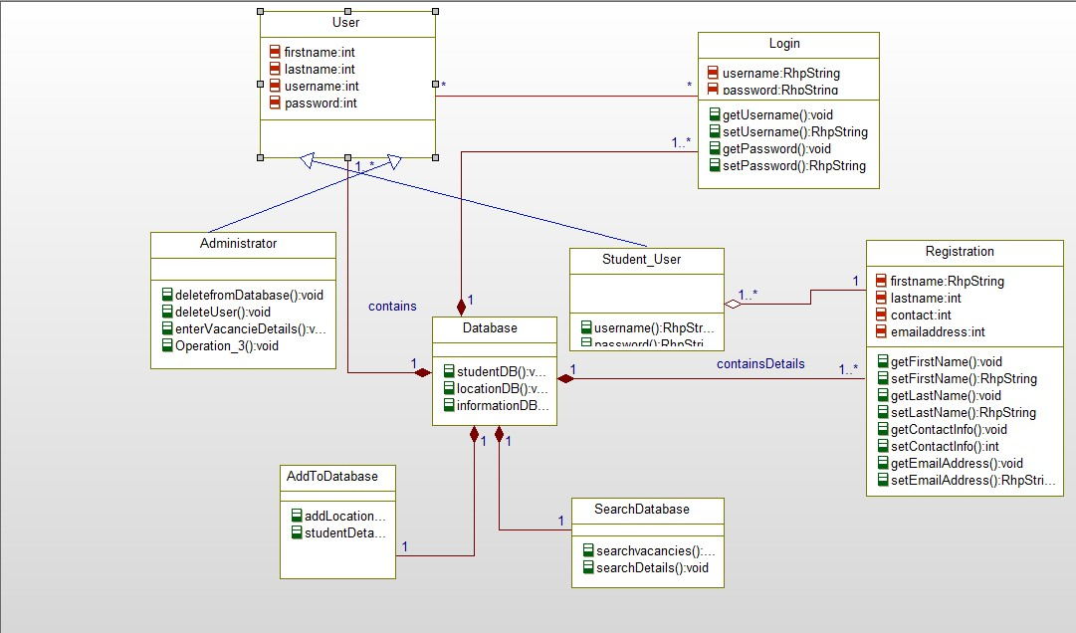

**IMPLEMENTATION:**

**a) Implementation of User Interface:**

The first increment covers the design of the basic user interface for our login and registration form for students and administrator.

Upon request to the URI, a home page is displayed with two buttons, Student Login and Admin Login.

On request for Student Login, a new page will be opened that asks for registration. A new user must register to the application for further access by entering their details. All the registration details are validated for proper data entry.

After completion of the registration, a student has to log-in with the provided userid and password. On successful login, the student is provided with specific fields to search for the information about the available vacancies.

On request for Admin Login, a new page is triggered with log-in details. The log-in details are validated through reusable validation functions. If the admin is successfully logged into the account, he is given privileges to add the housing details such as, available vacancies, address and other contact information.

For all the above log-in and registration forms, validation is done for text fields, passwords and other contact information.

**b) Implementation of Test Cases: Test Cases:**

|  |  |  |  |  |  |
| --- | --- | --- | --- | --- | --- |
| **Test-Case** | **Check Item** | **Test case**  **objective** | **Execution**  **Steps** | **Test Data** | **Expected**  **Output** |
| 1 | Log-in page | Click log-in  button by leaving all the fields empty/blank | Click log-in  button |  | If all the fields  are empty, a mandatory (*) symbol will appear to the username and password |
| 2 | Username | Enter invalid  username |  | Username:  Sne23a | An error  message appears as “Enter valid username” |
| 3 | Username | Enter valid  username |  | Username:  Sneha | It should allow  the student to proceed to |

|  |  |  |  |  |  |
| --- | --- | --- | --- | --- | --- |
|  |  |  |  |  | enter further  details. |
| 4 | Password | Enter correct  password |  |  | The entered  password should be displayed in encrypted format. |
| 5 | Password | Enter wrong  password |  | Password: *** | An error  message “Please enter valid  password” is  displayed |
| 6 | Log-in | Correct inputs | Click Log-in |  | On successful  log-in, it should trigger to respective new page |
| 7 | Forgot  Password |  | Click forgot  password |  | Password will  be recovered by using the link given |
| 8 | Registration |  | Click  registration button |  | On click to  registration button a new page will be directed to a new page to enter registration details |

**Test Requirements:**

Username:

- should contain numbers, letters and period

- should not be more than 15 characters

- should not start with any symbols

-should not contain any symbol, period or space

-should not be blank

**Test Scenarios:**

• Verify if all the specific fields on the registration form are available

• Verify that all the mandatory fields on the registration form are marked with symbol (*). If the user fails to enter the mandatory fields, the web page will not redirect to a new page.

• Verify that the page has submit button after all the fields

• Verify that the validation of user must be done at client side.

• Verify the email address of the students

• Check for validation error if the user enters blank space in mandatory fields

• Check for validation error if the user submit the log-in without entering all the required fields.

**User Interface:**

• The user name and password text fields should be in order

• New users should be provided with register link that redirects to a new page where registration form is triggered.

• User interface should match the specifications of the application

• On click to the submit button, the page must be redirected to new page where search can be performed.

**DEPLOYMENT**

1) ScrumDo Link:

[**https://www.scrumdo.com/projects/project/student_accommodation/iteration/122907**](https://www.scrumdo.com/projects/project/student_accommodation/iteration/122907)

2) GitHub (Source Code)

[**https://github.com/ManushaReddy/GitHub/blob/master/ASE_Project.zip**](https://github.com/ManushaReddy/GitHub/blob/master/ASE_Project.zip)

3) GitHub (Report)

[https://github.com/ManushaReddy/GitHub/blob/master/Project%20Report%20Increment%201](https://github.com/ManushaReddy/GitHub/blob/master/Project%20Report%20Increment%201.docx)

[.docx](https://github.com/ManushaReddy/GitHub/blob/master/Project%20Report%20Increment%201.docx)

**REPORT**

**Implementation of services:**

The following page allows the users access the home page of our website.

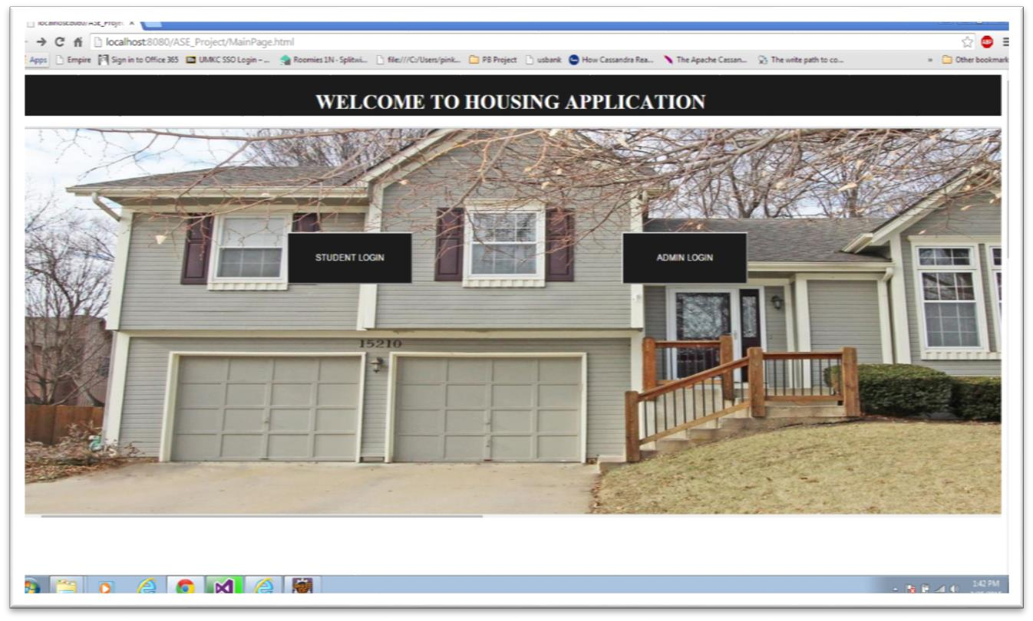

**The following log-in page allows administrator to log-in into his account by providing his username and password.**

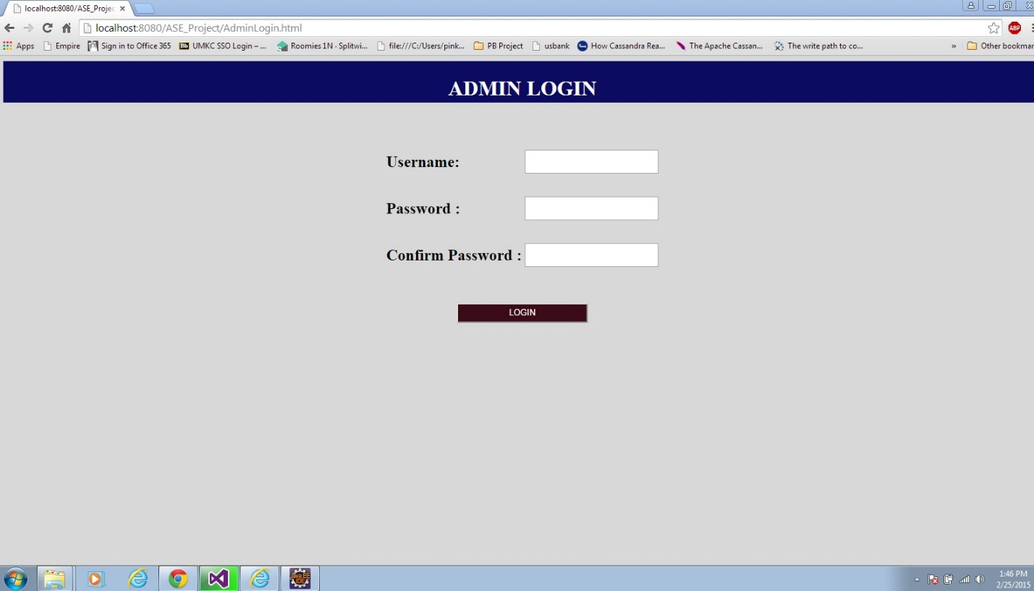

**The following page allows administrator to enter the details of the location and other contact information about the available vacancies.**

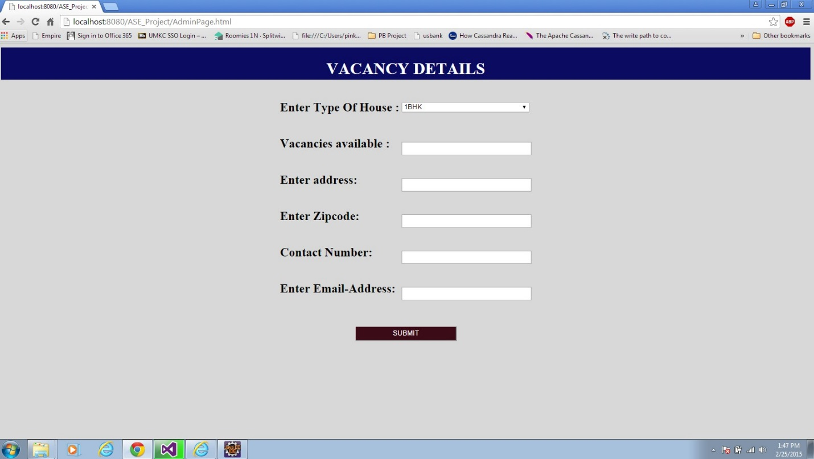

**The following registration page allows students to register to the system for further access**

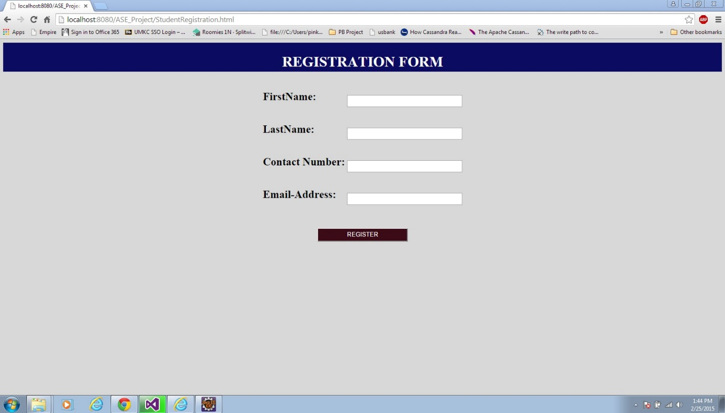

**The following log-in page allows students to login to the system provided they are already registered to the system.**

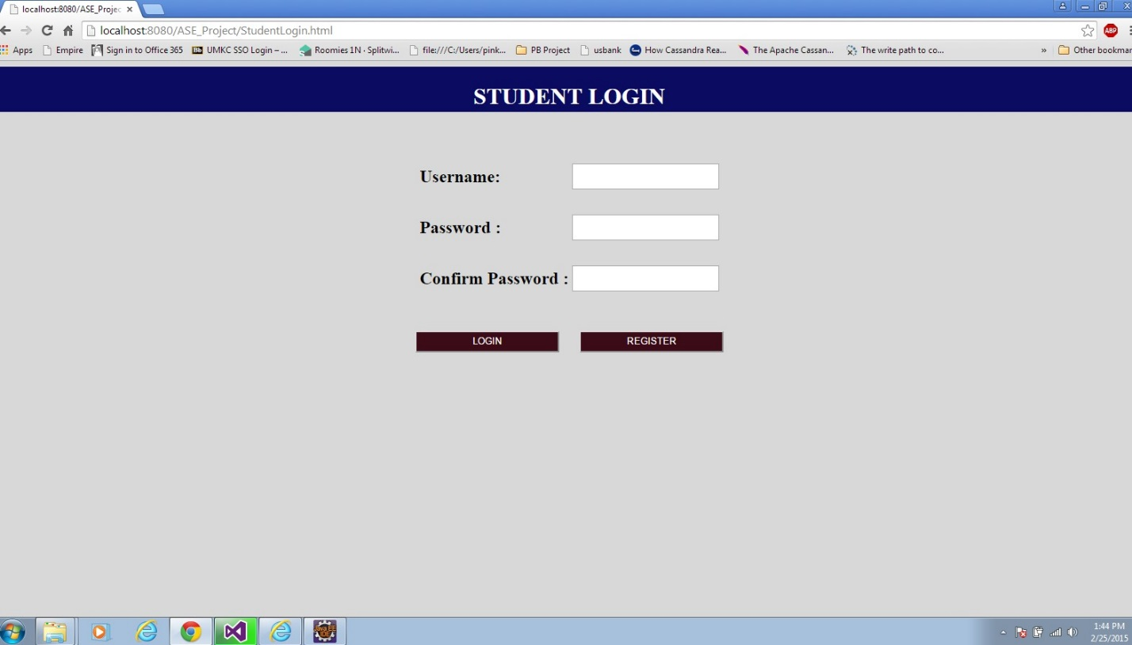

1. **INCREMENT 2**

**IMPORT EXISTING SERVICES:**

In the second increment, validations for all the log-in and registration forms have been created for student and administrator access. Database is created to store the details of students and to store the details of vacancies available at a particular place. Hence, no existing web services were used so far in the second increment.

However, for the further increments, we are to implement the following APIs:

User Feedback API: [http://api.sandbox.freelancer.com/User/getUserFeedback.{xml|json}](http://api.sandbox.freelancer.com/User/getUserFeedback.%7bxml|json%7d)

Geo Location API: <https://developers.google.com/maps/documentation/business/geolocation/>

Direction Service API: <https://developers.google.com/maps/documentation/directions/>

Facebook API: <https://facebook.com/share/>

Twitter API: <https://twitter.com/share/>

Source code for the so far developed application is uploaded in GitHub.

**DETAIL DESING OF SERVICES:**

* **User stories for second increment**

The second increment includes creation of database for the storage and retrieval of student information and house vacancies details.

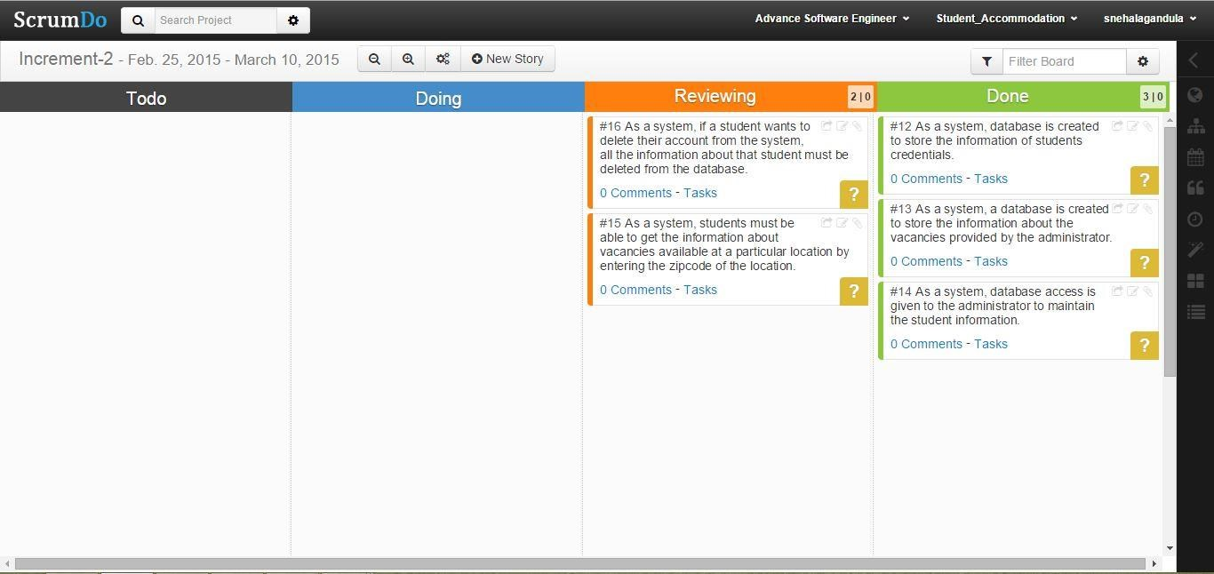

**Increment 3:**

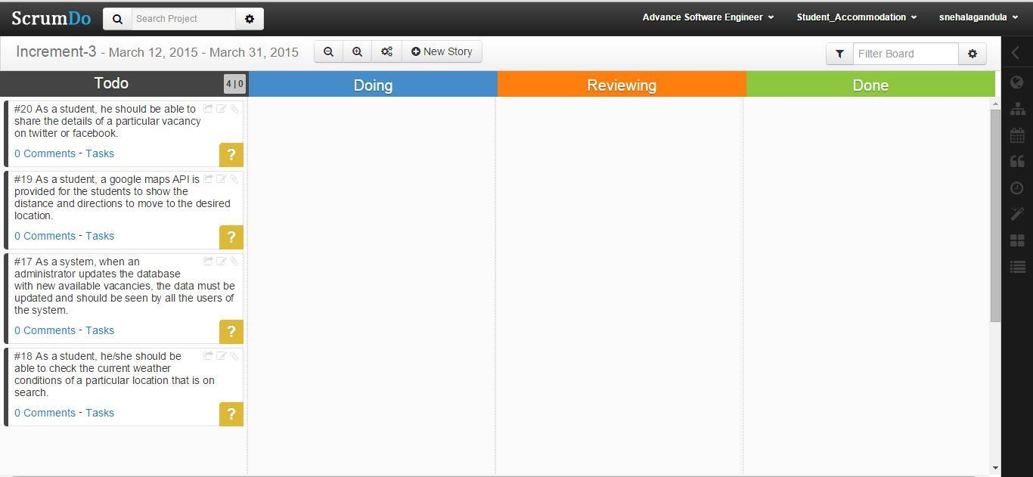

* **Design of Mobile Client Interface**



User



Web Application



Connection Pool



Database



Database

connection

SQL Query

Formatted

Response

* **Sequence Diagram**

A sequence diagram is an interaction diagram that provides the collaboration of objects depending on a particular time sequence. The following is the sequence diagram that shows the flow of processes that operates one after the other in a certain order. The sequence diagram is to show the flow of student registration and login form with certain validations.

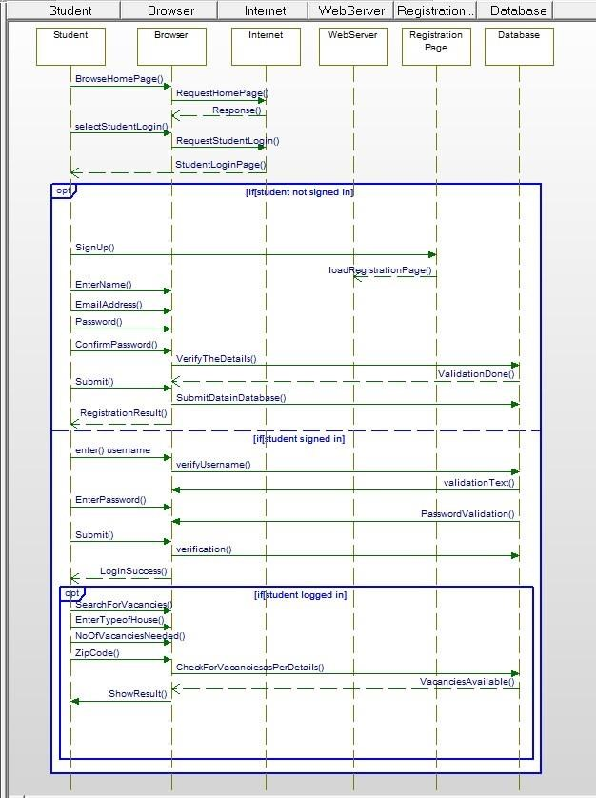

**Sequence Diagram for AdminLogin:**

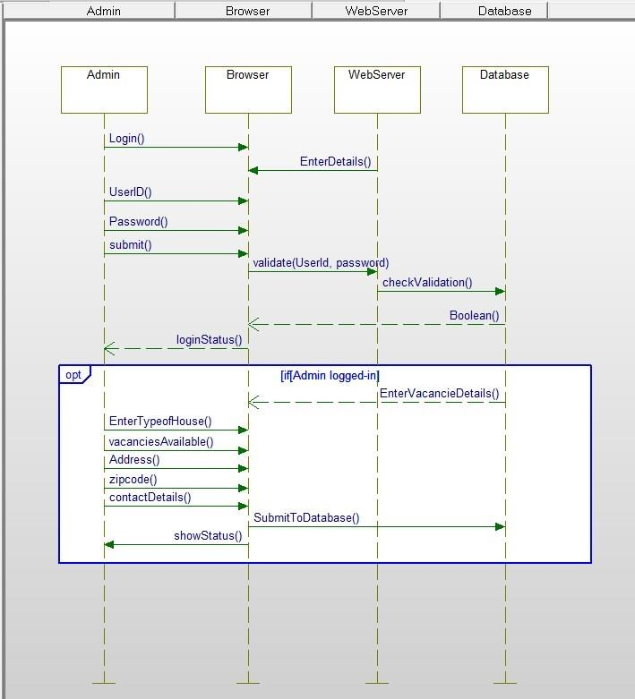

* **Class Diagram**

A class diagram identifies the structure of the application by describing the relationship between the objects and classes of the system.

The following class diagram describes a student or an administrator log-in to the website.

The system has two types of users, student user and the administrator. The student logsin to the account only if the student is already registered in to the system. The student or admin logs-in to the system by entering the username and password, the system then validates the provided log-in details, and if successful, the system connects the user to the account for further access. If not successful, the system allows repeated attempts to the user and prevents the entry until the log-in is successful.

Database is created to store the information about the vacancies available at a certain location. When a student registers for the application all the details of the students are stored in a database for authorization. When a user logs in to the system, the entered details are checked in the database, if the details are availed in the database, further access is given to the system.

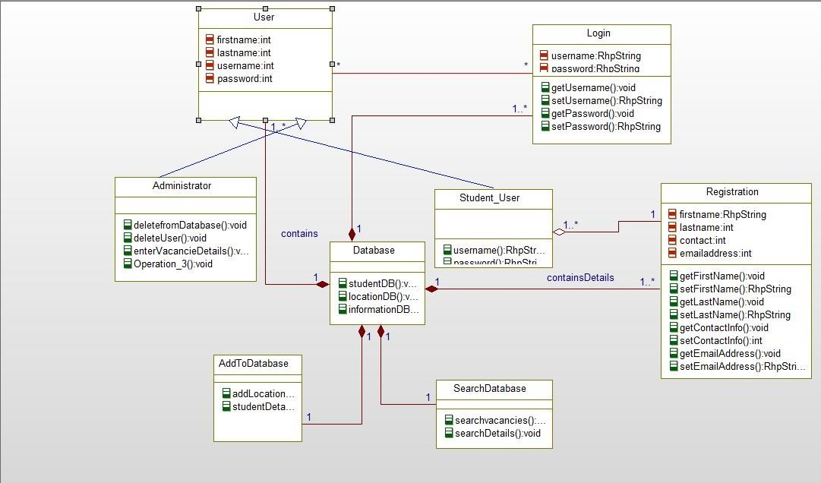

**IMPLEMENTATION:**

* **Implementation of User Interface**

The second increment covers the storage and retrieval of student data from the database.

When a student registers to the system, all the information about the student that is provided in registration form will be stored in to the database. After a successful registration, student can login to the system for further access. When the student logs in to the system, his/her credentials must be validated from the database. If the student is already registered for the application, and if the credentials provided by the student matches its respective fields in database, then a further access will be provided to the user.

* **Implementation of Test Cases** o **General Test Scenarios** 
  + All the mandatory fields must be represented using asterisk symbol
  + Error should be displayed at a correct position
  + All the error or incorrect data should be displayed using same CSS styles
  + Reset functionality should be set, if user wants to clear the values in all the fields.
  + Application unavailable or crash should redirect to a new page that shows an error.
  + All fields on page should have the same alignment.
  + Scroll bar should be available when necessary
  + All pages must have their respective titles
  + Before performing any delete or update operation, confirmation message should be displayed.
  + Using all the parameters on the page, user should be able to filter the page.
  + Check whether the size of the window is resizable.

o **Database Testing Test Scenarios:**

* + Table should have primary key in a column
  + Upon a page submit, check whether the data saved into database is correct.
  + Database name should be given depending on the type of the page created.
  + Length of the filed that is shown on the web page should be same as its length in database field.
  + Database fields should be designed with correct data type and data length.
  + Check the datatypes and its properties of their fields in database.
  + Verify the data in the database.
  + Logical names for the database are given according the database name.
  + For primary key column in database, null values should not be allowed.
  + All the required data tables must be created.

**DEPLOYMENT:**

* ScrumDo Link:

[http://www.scrumdo.com/projects/project/student_accommodation/iteration/122911/board#](http://www.scrumdo.com/projects/project/student_accommodation/iteration/122911/board)

* GitHub (Source Code):

<https://github.com/dheerajreddy8/ASE-Project>

**REPORT:**

The following page allows the users access the home page of our website.

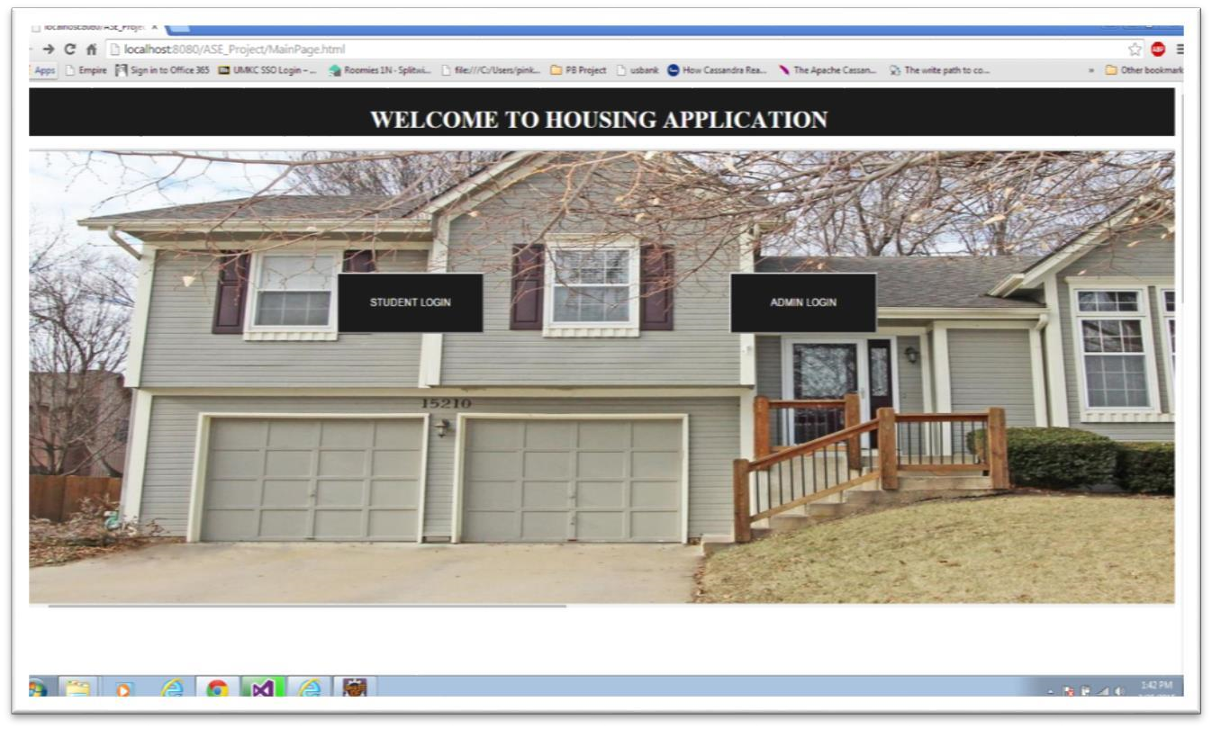

**The following log-in page allows administrator to log-in into his account by providing his username and password**

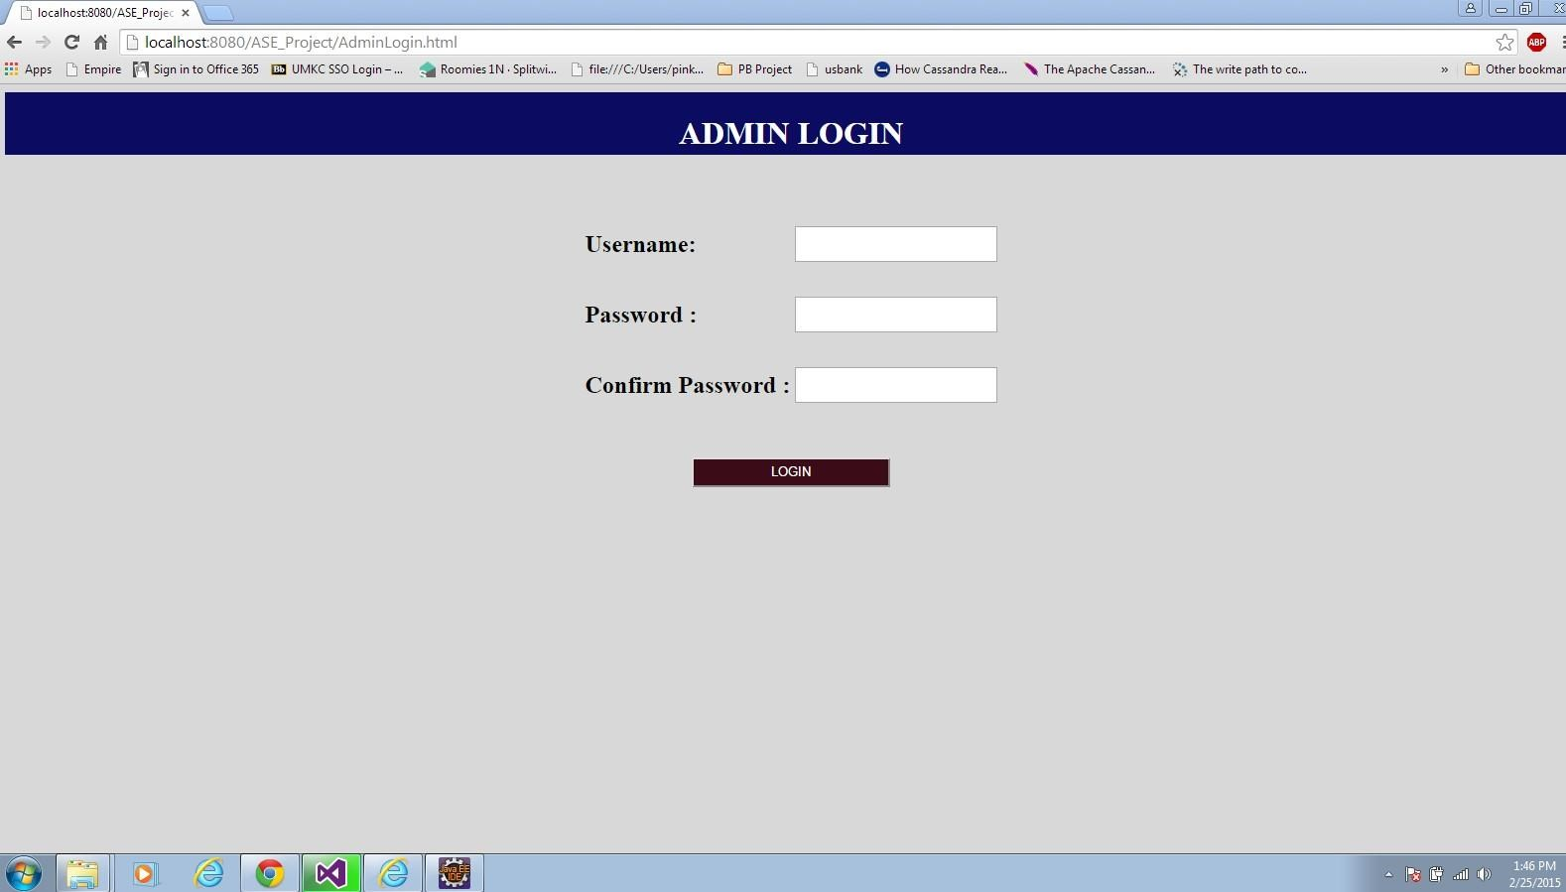

**The following page allows administrator to enter the details of the location and other contact information about the available vacancies.**

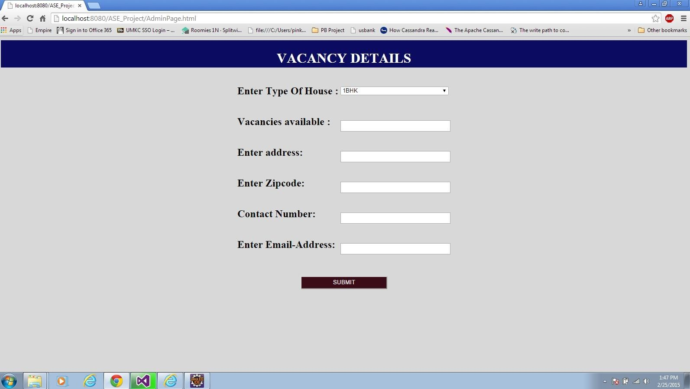

**The following registration page allows students to register to the system for further access**

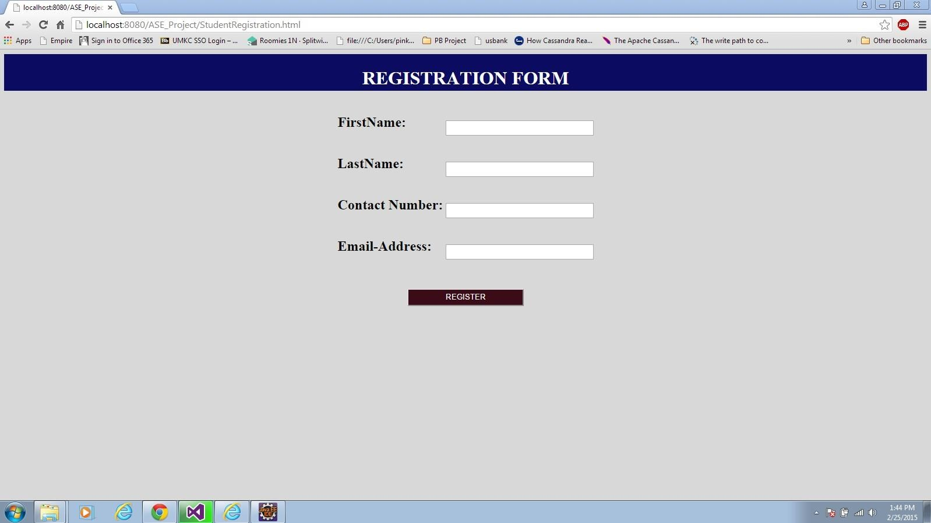

**The following log-in page allows students to login to the system provided they are already registered to the system**

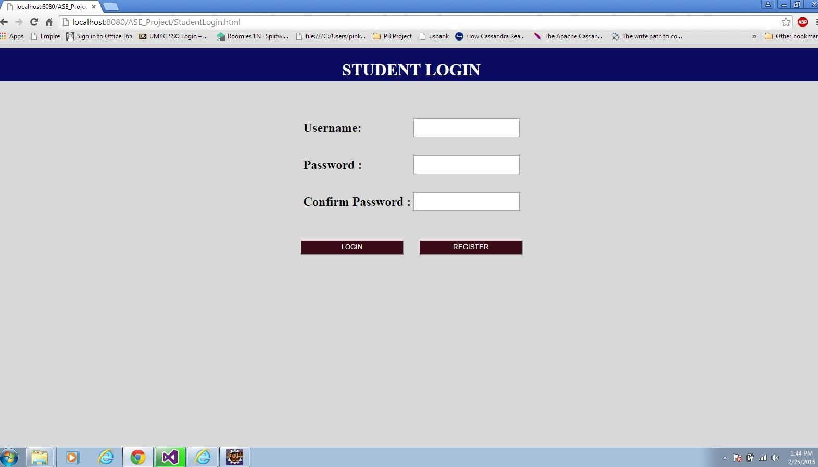

**The following page allows students to search for the vacancies at a particular location**

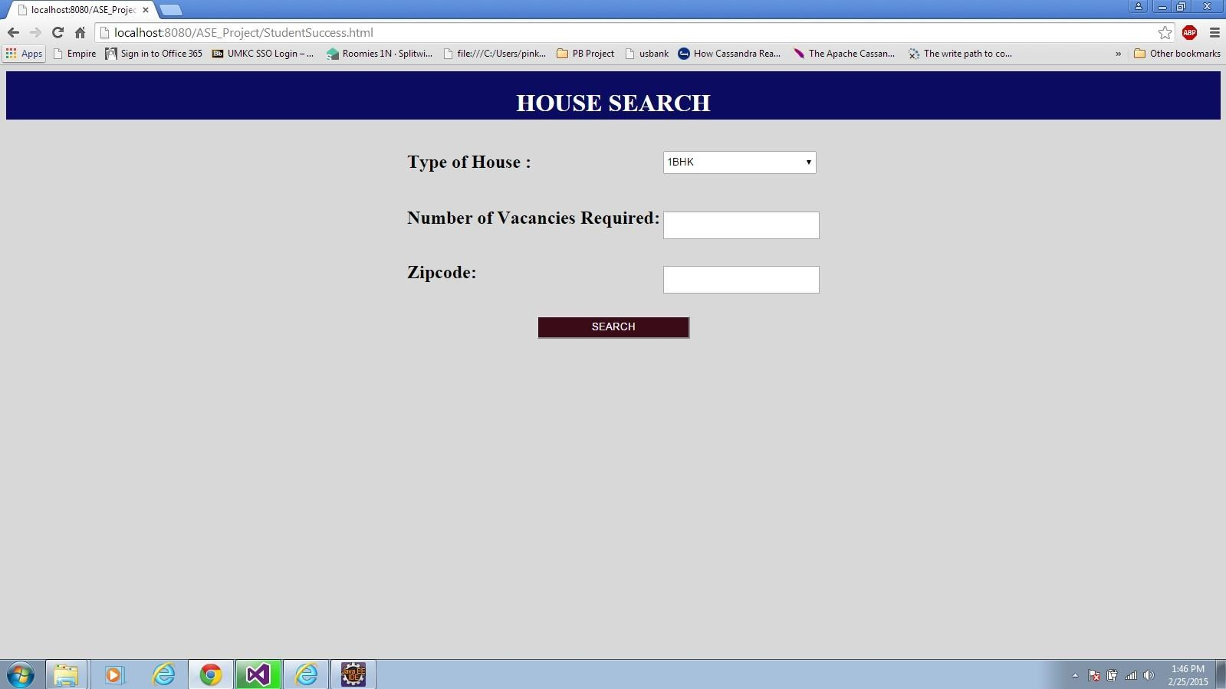

For the second increment, work was on front end as well as on back end. Database is created for storage and retrieval of student and administrator information.

1. **INCREMENT 3**

**IMPORT EXISTING SERVICES:**

In the third increment, bootstrap framework is integrated with web application to enhance the user interface of the application. Validations for all the log-in and registration forms have been created for student and administrator access. Database is created to store the details of students and to store the details of vacancies available at a particular place. Upon search for the accommodations at a particular location, all the details of the available vacancies along with google maps is provided. The google maps is used to check for the weather conditions at that particular locations as well as to calculate the distance from university to the desired location. Google and Twitter API are implemented to share the details of a certain available vacancy to public.

Hence, we used Facebook API, Geo Location API, Twitter API, and Direction Service in the third increment.

Geo Location API: https://developers.google.com/maps/documentation/business/geolocation/

Direction Service API: https://developers.google.com/maps/documentation/directions/

Facebook API: https://facebook.com/share/

Twitter API: <https://twitter.com/share/>

However, for the further increments, we are to implement the following APIs:

User Feedback API: http://api.sandbox.freelancer.com/User/getUserFeedback.{xml|json}

Source code for the so far developed application is uploaded in GitHub.

**DETAIL DESIGN OF SERVICES:**

* **User stories for third increment**

Third increment includes the enhancement of user interface using bootstrap. External APIs such as Facebook API, Twitter API, and Google Maps API are added to the application.

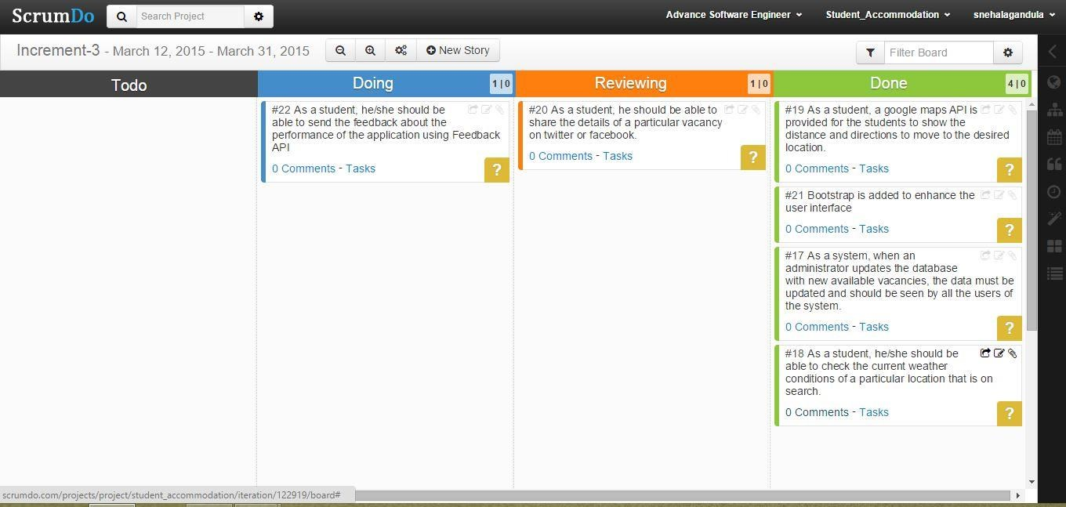

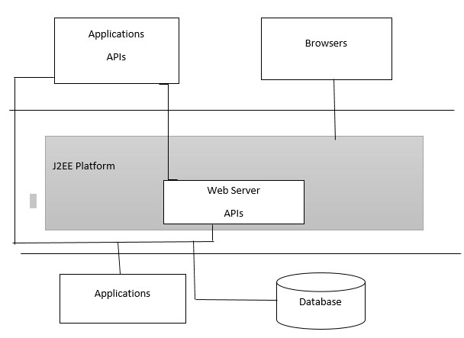

**Class Diagram for External API:**

External APIs such as Google Maps API, Facebook API, and Twitter APIs are added to the application. Up on search at a particular location, a table with available vacancies will be displayed along with google maps that shows route from the university to the desired location.

Facebook and Twitter APIs are used by the users to share the detailed information of an available vacancy.

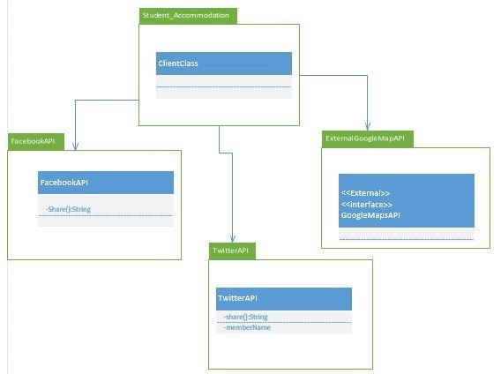

**IMPLEMENTATION:**

• **Database Testing Test Scenarios:**

* Table should have primary key in a column
* Upon a page submit, check whether the data saved into database is correct.
* Database name should be given depending on the type of the page created.
* Length of the filed that is shown on the web page should be same as its length in database field.
* Database fields should be designed with correct data type and data length.
* Check the datatypes and its properties of their fields in database.
* Verify the data in the database.
* Logical names for the database are given according the database name.
* For primary key column in database, null values should not be allowed.
* All the required data tables must be created.

**TESTING:**

Testing is an important component in software development process. Testing is done to check the quality of the software that works at crucial circumstances.

**Performance Testing:**

* **Firebug Testing:** This acts as an extension to the web browser by supporting debugging and testing of the website. It also helps in monitoring the website.

We have tested home page of our web application using firebug:

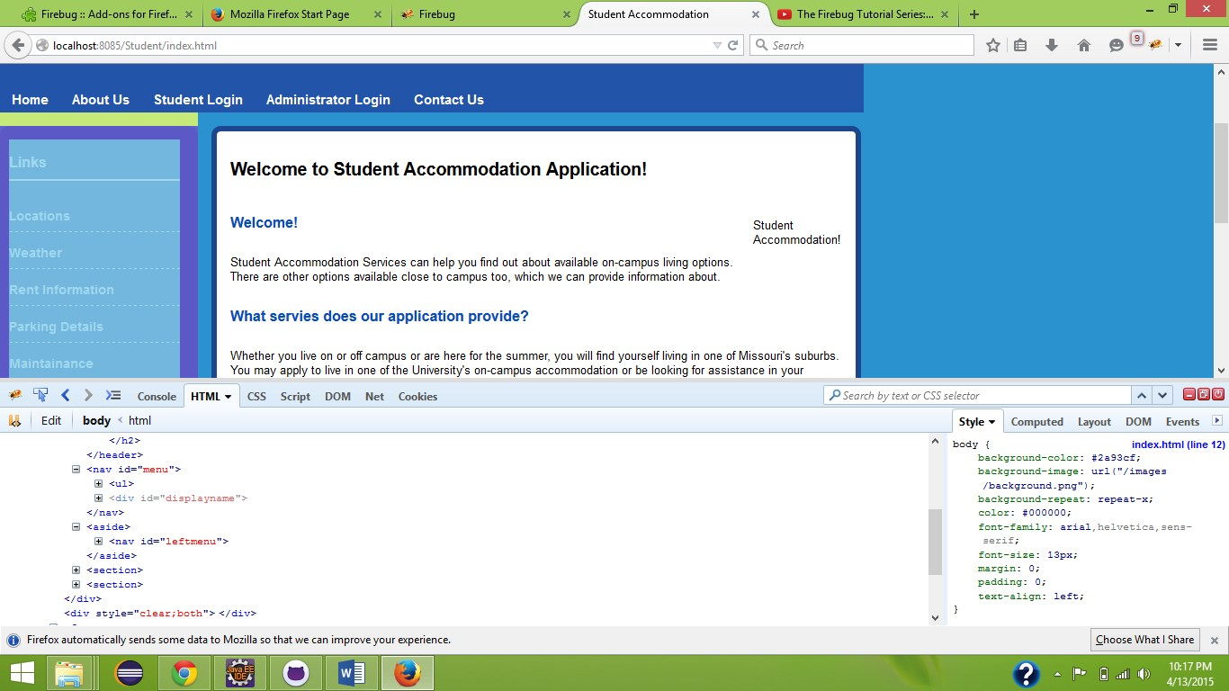

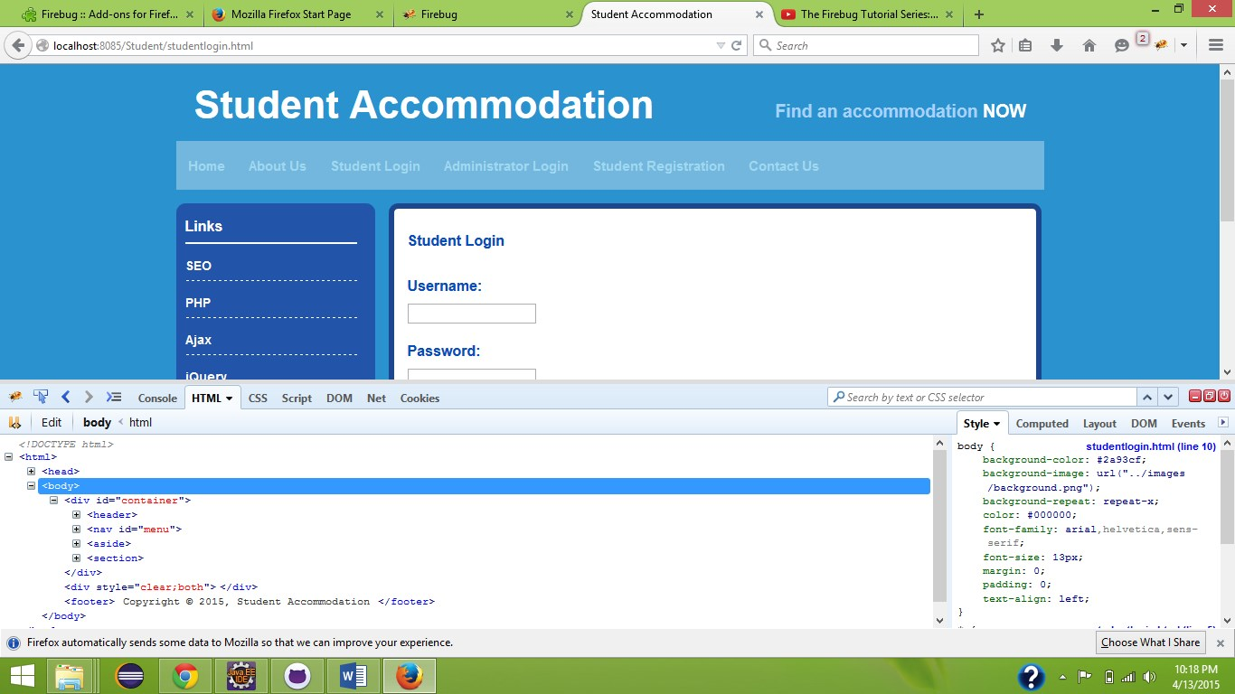

**Firebug testing for list items**

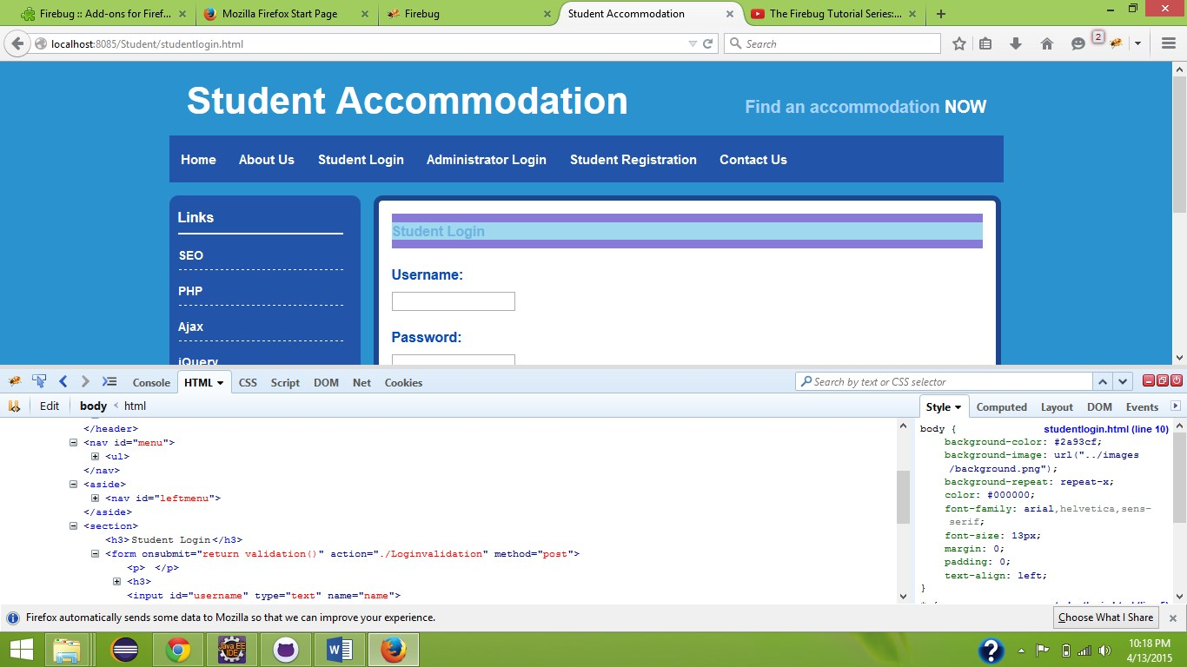

**Firebug testing for student login**

**DEPLOYMENT:**

* ScrumDo Link:
* [https://www.scrumdo.com/projects/project/student_accommodation/iteration/12291 9/board](https://www.scrumdo.com/projects/project/student_accommodation/iteration/122919/board)

* GitHub (Source Code):

<https://github.com/snehalagandula/Increment3-PG11>

**REPORT:**

The following page allows the users access the home page of our website.

Home Page:

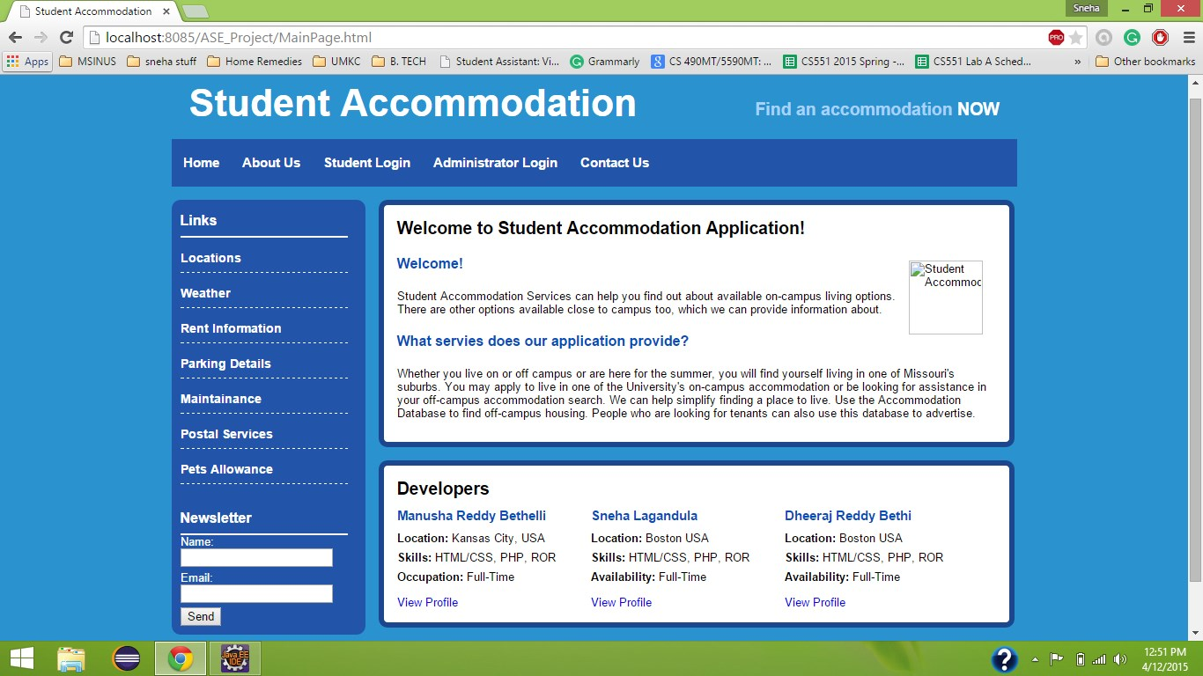

Student Login:

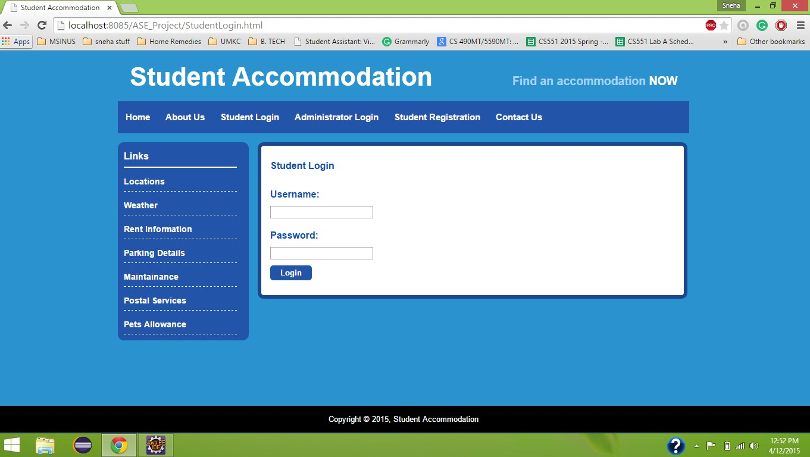

Search for Vacancies:

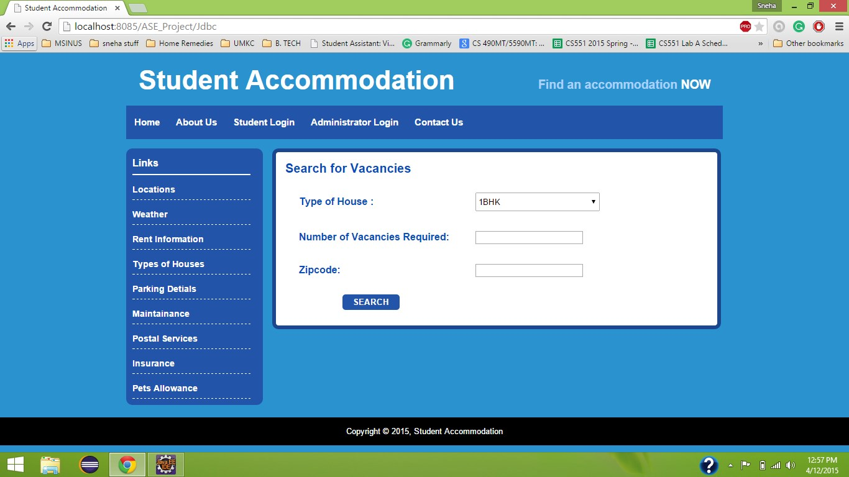

Student Failed to Login

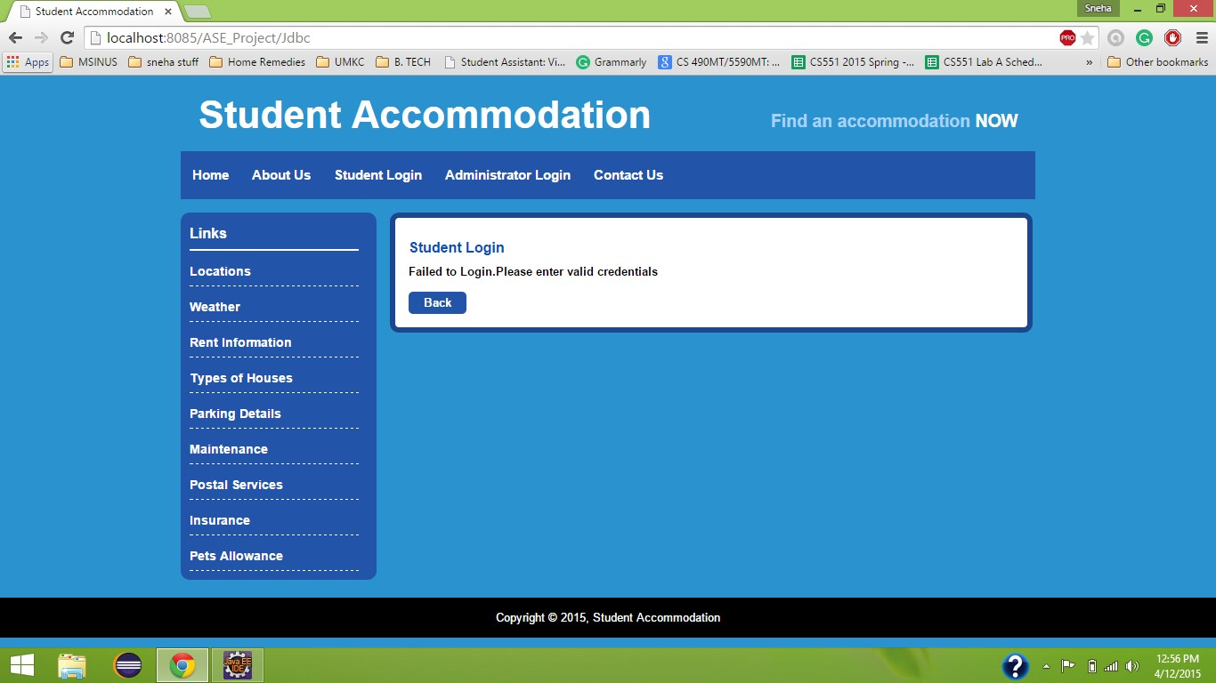

Administrator Login

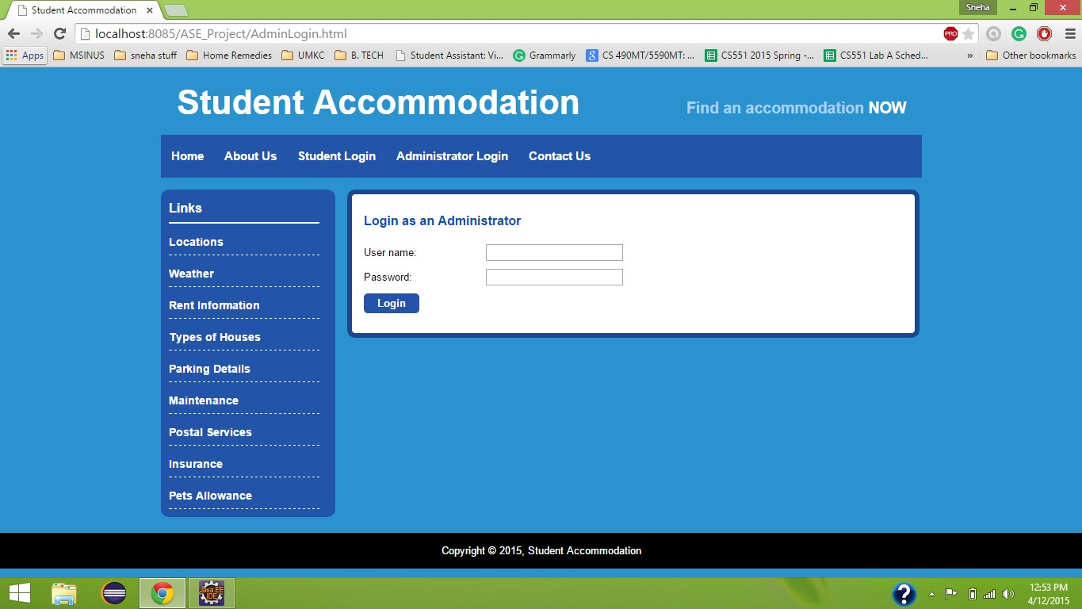

Updating with new available vacancy details

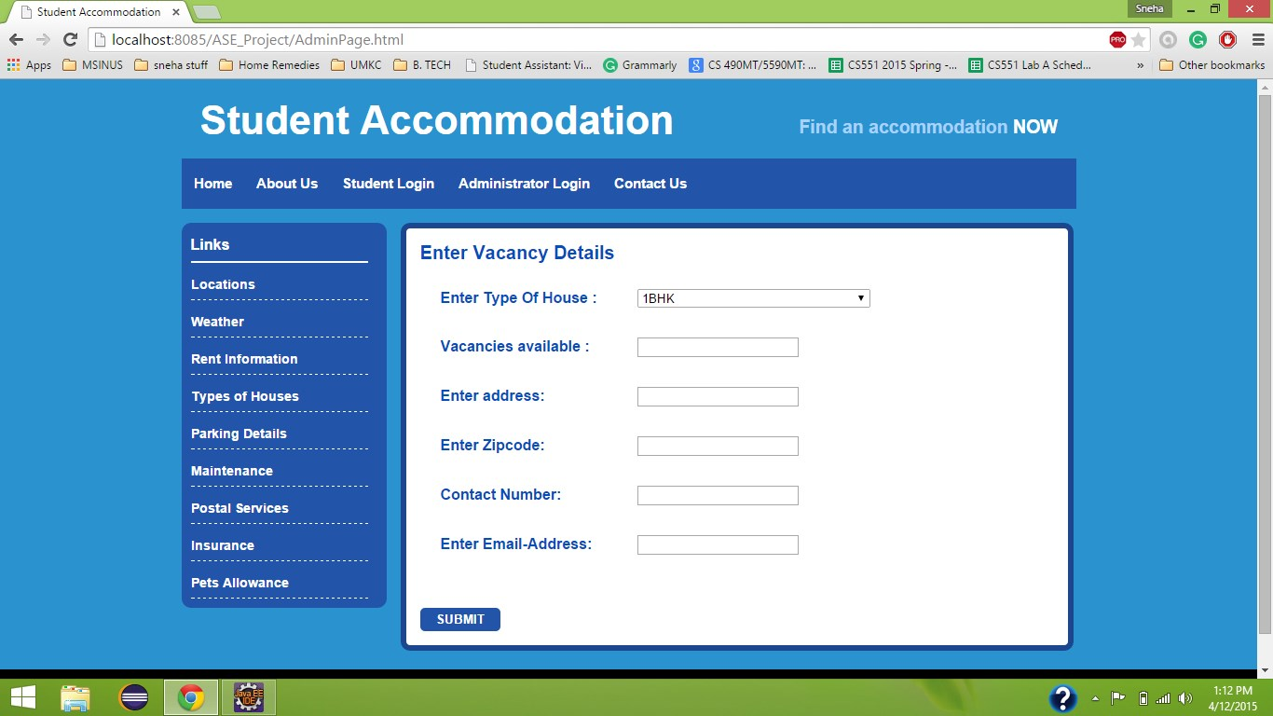

Contact Information

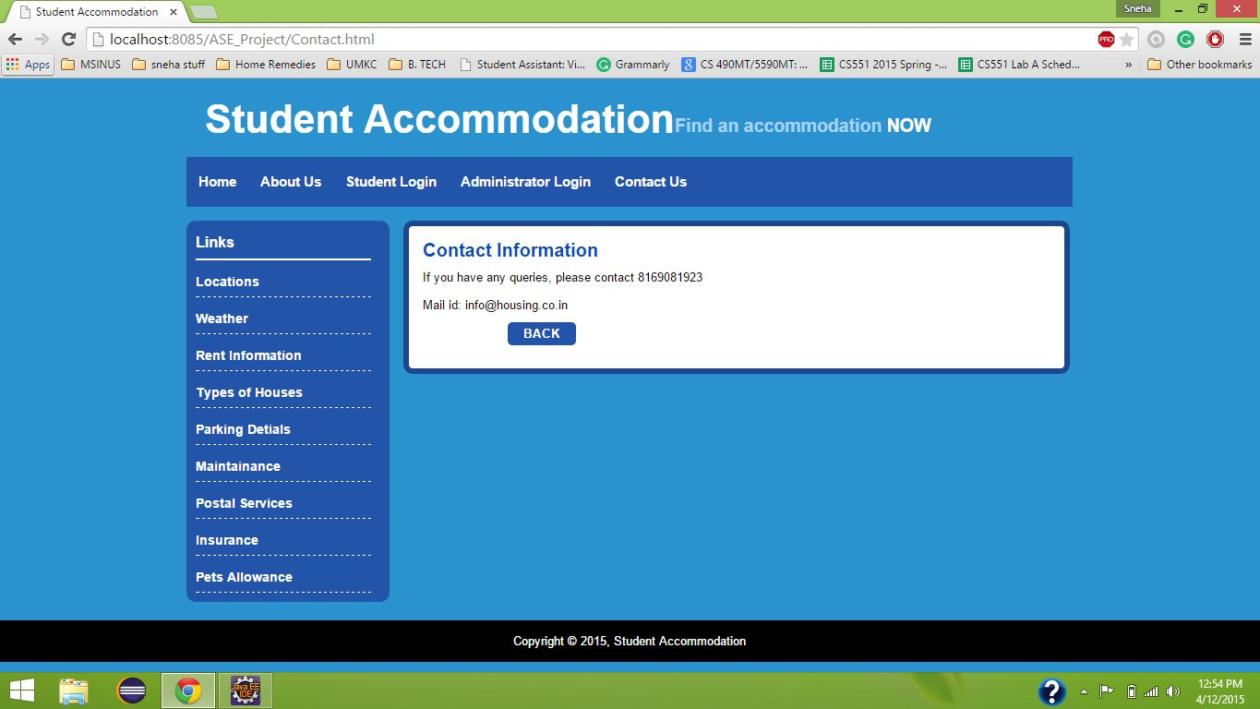

Database before Registration:

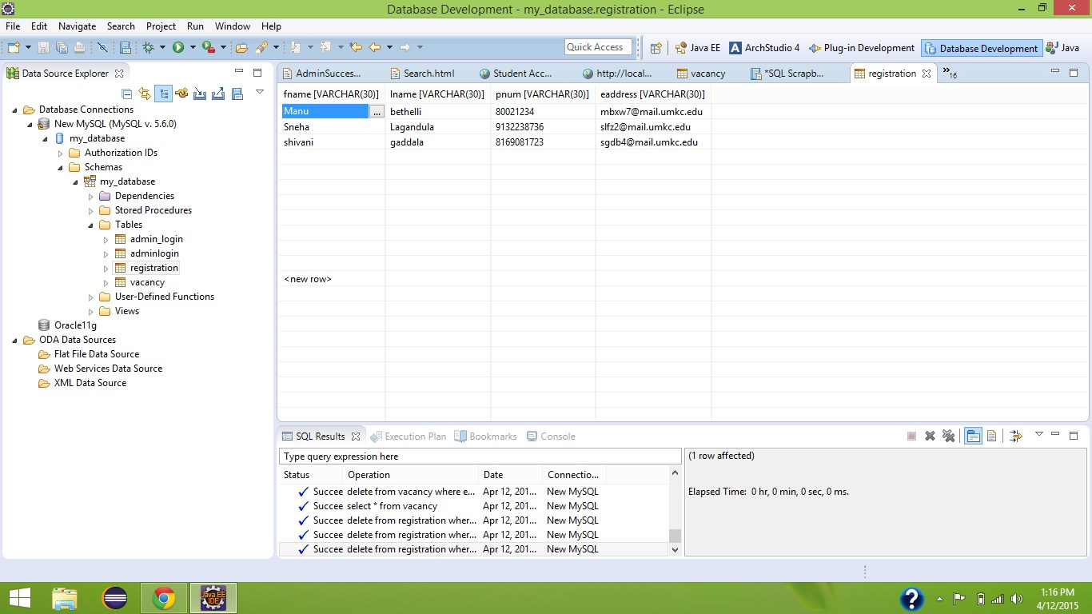

Details stored into database after registration

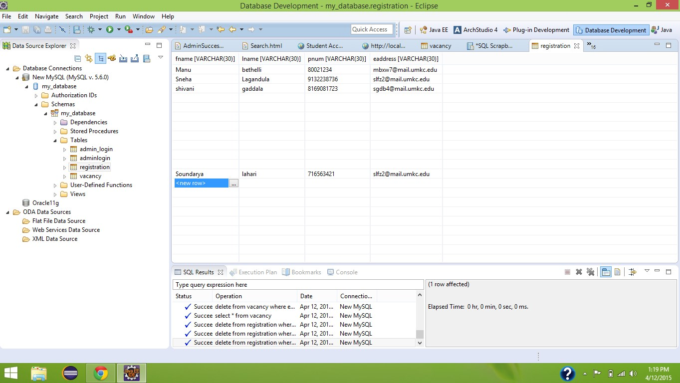

Student Registration

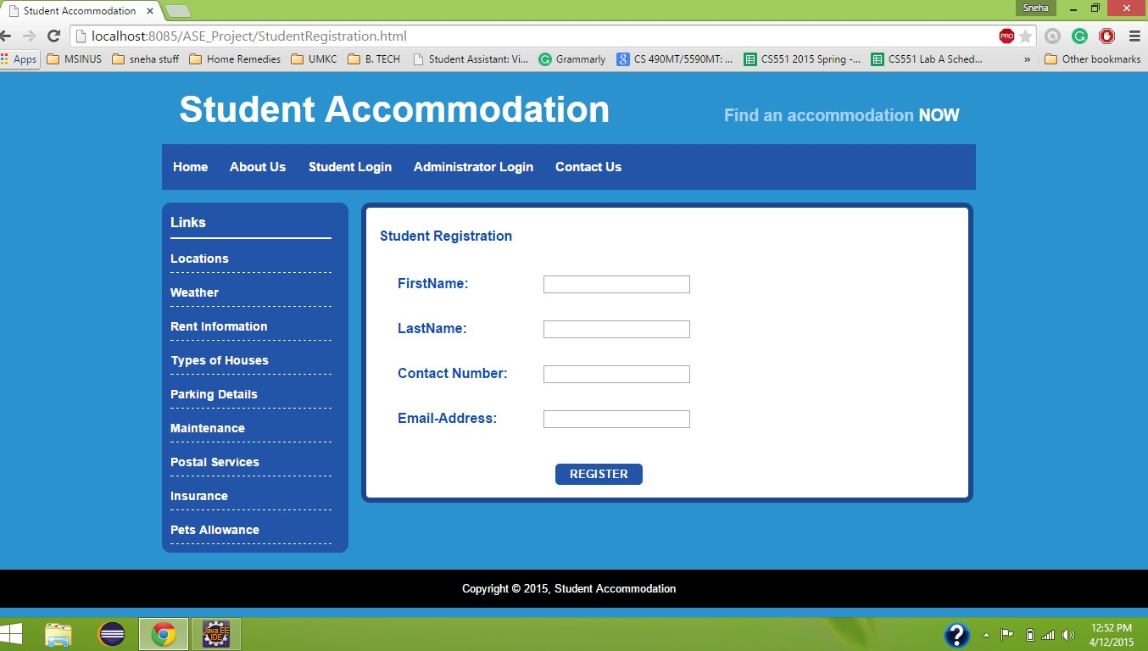

1. **INCREMENT 4**

**INTRODUCTION**

In the world of modern technology where the internet market has seen a revolution, Internet has been an epicenter for it. About 70% of the students’ population use Internet. The project “Student Accommodation” web Application uses simple and effective design to help students find accommodations anywhere near their universities on the move. This application is given access to all the students in the university using their students ID’s as a primary key. This application needs internet connection to search for places near the University for an Accommodation. All the places with vacancies near the university can be found along with a route map from the university to the desired location in search. Our aim is to help students find the accommodation that most suited to their needs as easily and as quickly as possible. We realize how essential it is to find the right student accommodation for a proper and decent academic lif**e.**

**PROJECT OBJECTIVE**

The objective of this application is to provide students with proper information about the available and convenient vacancies for accommodation. Also, provides the students with contact information about the available vacancies. Initially, a login registration form is granted. Students who wants to use the application can register. With the registration process, the student creates user name and password. These credentials are further used to login to the application. After a log in, students are provided with various features to search for the accommodation. Various search fields are provided with specific information such as ZIP code of the location, number of rooms required, preferred distance etc. The search result would be a list of vacancies that are available with in a specific location .Also, students are provided with additional information such as contact information, routing map from their current location to their desired location.

**IMPORT EXISTING SERVICES/API:**

In the fourth increment, we enhanced the features of the application by providing additional information such as rent information, parking details, maintenance, postal services, pets allowance to the users. Besides, searching the details of the vacancies that are shown up by our site, we are providing the users with additional apartment details and the maps to route to that location. All the apartments that are near to the university are stored in to the database and information about those apartments is provided.

The google maps API is used to route the user from his current location (geo location) to the location the user wish to move. Weather API is used to check for the weather conditions at that particular locations. Distance vector algorithm is used to calculate the distance from university to the desired location. Google and Twitter API are implemented to share the details of a certain available vacancy to public. An additional feature called, News Letter is added to the application. The user who is the registered member of the application can subscribe to the student accommodation application through email. When the user successfully subscribes to the site, all the newly availed vacancies will be notified to the users through emails.

We have implemented the following APIs:

**News Letter API**:https://sendgrid.com/docs/API_Reference/Marketing_Emails_API/index.html

**User Feedback API**: http://api.sandbox.freelancer.com/User/getUserFeedback.{xml|json}

**Geo Location API**: https://developers.google.com/maps/documentation/business/geolocation/

**Direction Service API**: https://developers.google.com/maps/documentation/directions/

**Google Maps with Distance Vector**: https://developers.google.com/maps/documentation/business/

**Facebook API**: https://facebook.com/share/

**Twitter API**: <https://twitter.com/share/>

Source code for the so far developed application is uploaded in GitHub.

**DETAIL DESIGN OF SERVICES**

* **User stories for fourth increment**

In the fourth increment,we enhanced the features of the application by providing additional information such as rent information, parking details, maintenance, postal services, pets allowance to the users.

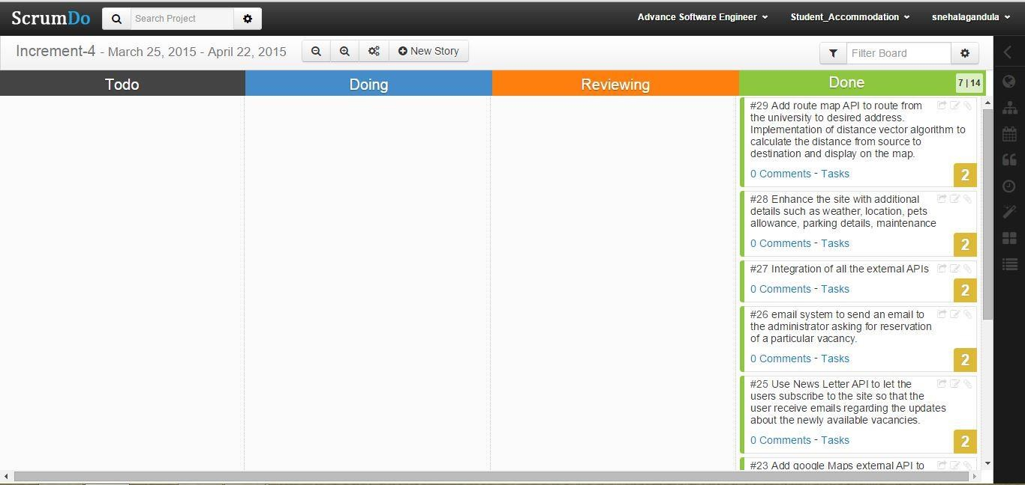

* **Search Mechanism used to find Vacancies** o Application offers search of the vacancies across the whole distributed database. It supports nested search with the previous search results. For instance, when the student searches for a vacancy at a certain location more than once, the new search is applied to the results of the previous search. This way, the search can be refined until the student finds the type of vacancy he was looking for.

* **Flow Diagram for Database Connection**

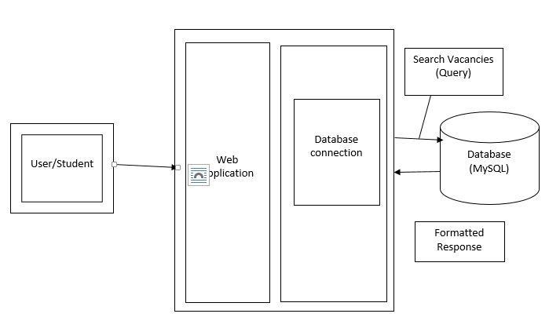

* **Sequence Diagram**

A sequence diagram is an interaction diagram that provides the collaboration of objects depending on a particular time sequence.

The following is the sequence diagram that shows the flow of processes that operates one after the other in a certain order. The sequence diagram is to show the flow of student registration and login form with certain validations.

▪

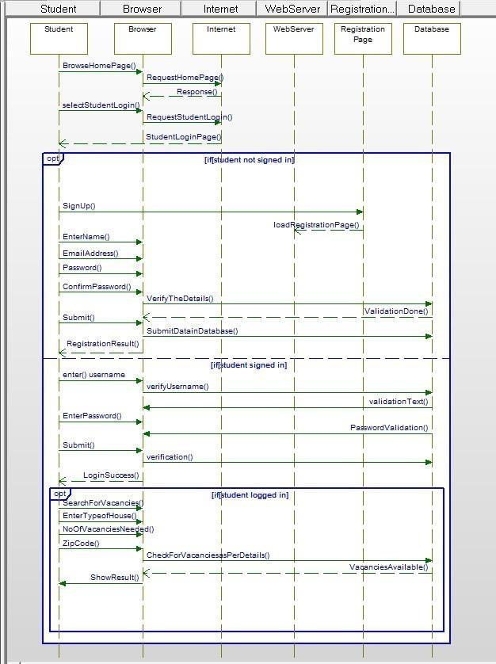

The following sequence diagram is used for the administrator to login to the system with the preassigned username and password. The administrator can add the details of the vacancies that are available at a certain location. When a particular vacancy is filled or booked by someone else, the details of that vacancy will be removed from the database to make the search easier.

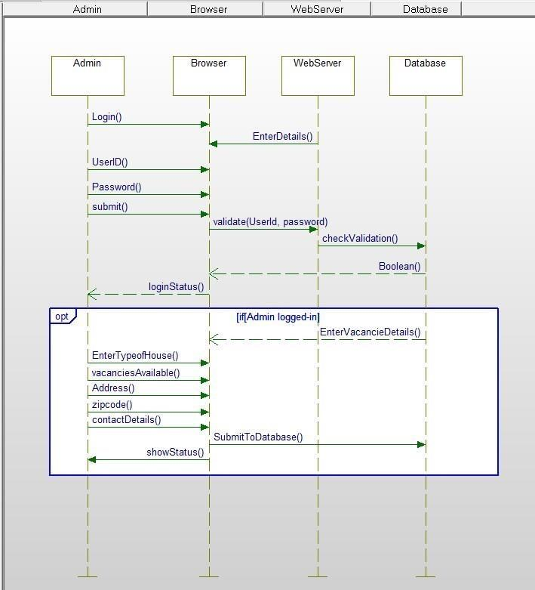

**Sequence Diagram for Password Reset:**

The following sequence diagram is used to reset the student password. The user first reset the password by submitting his email address. A random 6 digit code is generated and sent to given email address. Now, the password can be reset by entering the random 6 digit code along with a new password.

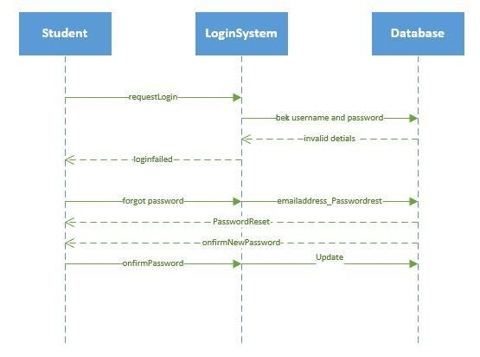

**Sequence diagram representing entire flow of the application:**

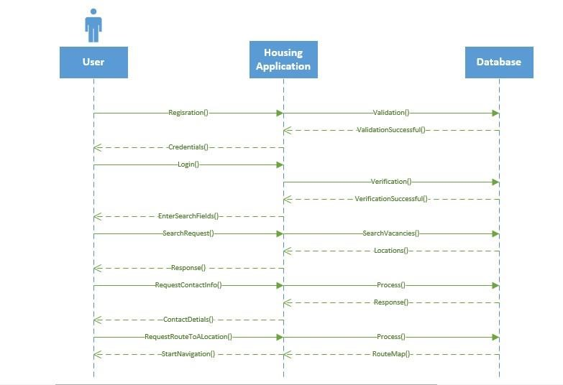

• **Class Diagram**

The following class diagram describes a student or an administrator log-in to the website.

The system has two types of users, student user and the administrator. The student log-in to the account only if the student is already registered in to the system.

The student or admin logs-in to the system by entering the username and password, the system then validates the provided log-in details, and if successful, the system connects the user to the account for further access. If not successful, the system allows repeated attempts to the user and prevents the entry until the log-in is successful.

Database is created to store the information about the vacancies available at a certain location. When a student registers for the application all the details of the students are stored in a database for authorization. When a user logs in to the system, the entered details are checked in the database, if the details are availed in the database, further access is given to the system.

Upon Search for the accommodation at a certain location, a new page is displayed providing all the details about available vacancies at that location. Also, google maps from the university to the desired location is shown, this helps user estimate the distance from source to destination. We at the desired location can also be determined through Geo-locations.

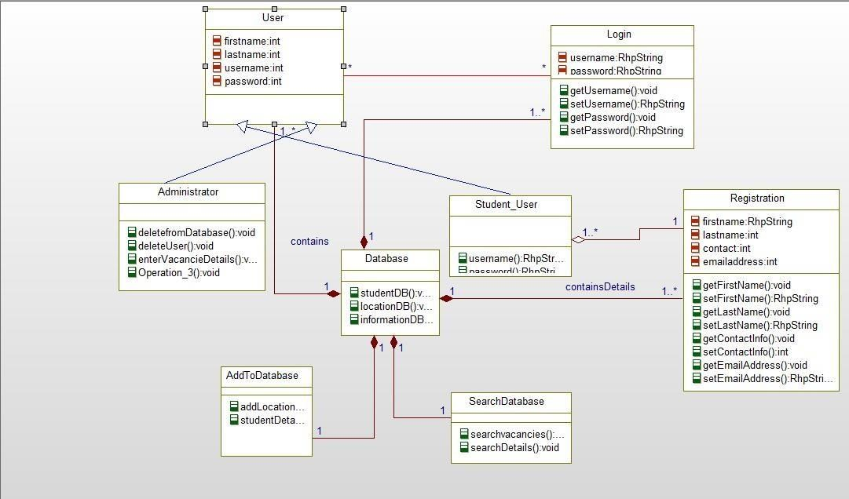

**Class diagram representing external API call:**

In this application, we have created interfaces for external APIs. The Facebook and Twitter APIs are used to share the details of certain vacancies to other user. The objective of News Letter is to make students who are already registered for the application to subscribe to the site. As the result of subscription, the user get updates about the newly available vacancies at their desired certain location. Feedback API is used to enter the feedback about the performance of the site. The given feedback will be received as an email to the developers. As a result, further improvements will be made according to the user requirements.

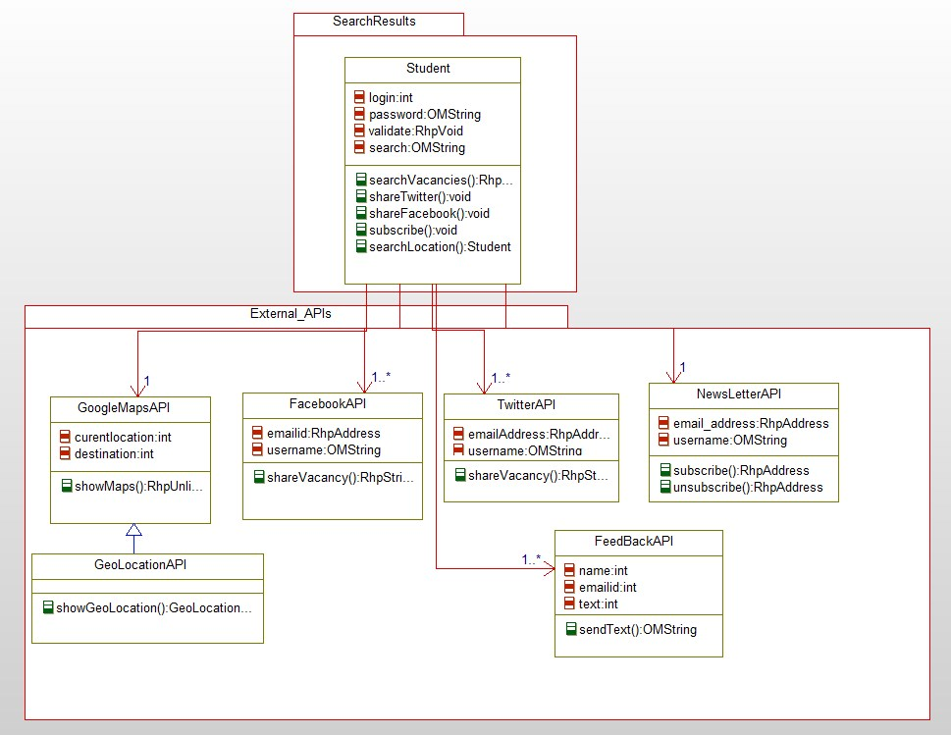

**Class Diagram representing the Email System in News Letter:**

In the feature called News Letter, the user who has registered to the site can subscribe to the application to receive emails about newly available vacancies that are updated by the administrator.

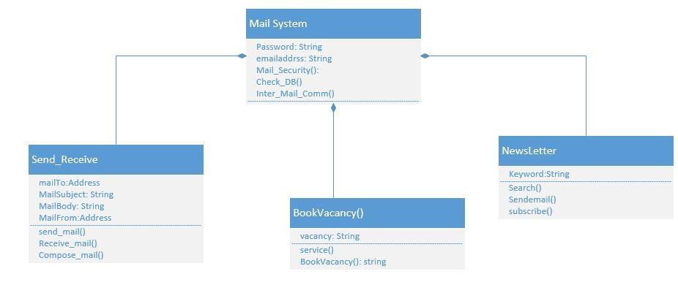

**Class diagram representing the email system to send an email to the administrator for booking a vacancy.**

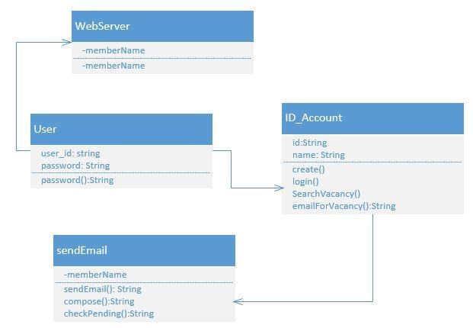

**IMPLEMENTATION:**

• **Implementation of Test Cases** o **Database Testing Test Scenarios:**

* + - Table should have primary key in a column
    - Upon a page submit, check whether the data saved into database is correct.
    - Database name should be given depending on the type of the page created.
    - Length of the filed that is shown on the web page should be same as its length in database field.
    - Database fields should be designed with correct data type and data length.
    - Check the datatypes and its properties of their fields in database.
    - Verify the data in the database.
    - Logical names for the database are given according the database name.
    - For primary key column in database, null values should not be allowed. ▪ All the required data tables must be created.
* **Search Result Grid Test Scenarios:** 
  + - A symbol representing the page load is shown when it takes longer time expected to load the page
    - Verify if all the search fields are filled to search for the vacancies
    - Total number of vacancies should be displayed in the form of a table
    - The search criteria that is used to search for a particular vacancy should be displayed.
    - Duplicate information should not be displayed.
    - A check box should be enabled to check a particular vacancy. As a result, the user can send an email to the administrator requesting for a reservation of a particular vacation.
    - Verify whether or not all the rows and columns are displayed on the web page.
* **Sending Emails Test Scenarios:** 
  + Check if email is sent to proper email address.
  + Check if the body of the email is in valid format
  + Check if the user is successfully subscribed to the newsletter.
  + Email address that the user use to subscribe should be same as the one with which the user register to the application.

**TESTING:**

Testing is an important component in software development process. Testing is done to check the quality of the software that works at crucial circumstances.

**Performance Testing:**

* + **Firebug Testing:** This acts as an extension to the web browser by supporting debugging and testing of the website. It also helps in monitoring the website.

We have tested home page of our web application using firebug:



**Firebug Testing for Home Page**



**Firebug testing for List Items**



**Firebug Testing for Student Login**

**DEPLOYMENT**

o **ScrumDo:**

[**https://www.scrumdo.com/projects/project/student_accommodation/iteration/122**](https://www.scrumdo.com/projects/project/student_accommodation/iteration/122921/board)

[**921/board**](https://www.scrumdo.com/projects/project/student_accommodation/iteration/122921/board) o **GITHUB:**

**REPORT:**

**The following is the home page of our application.**

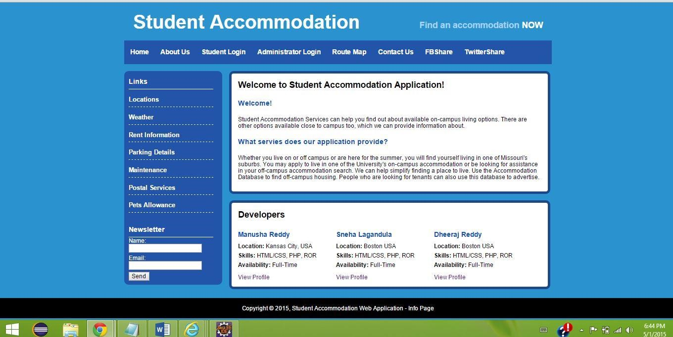

**The following page is About us page where the user is provided with details about house accommodation process.**

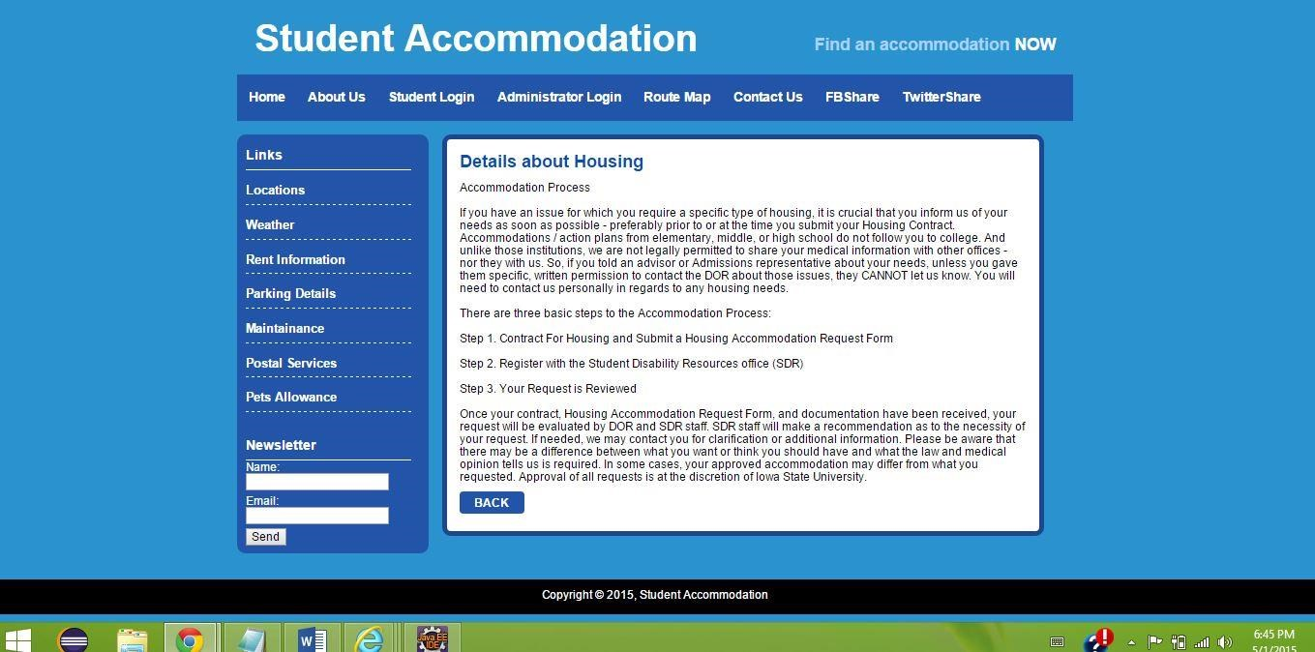

**The student can login to the system if and only if he is already registered to the application. The user is provided with password reset and registration form.**

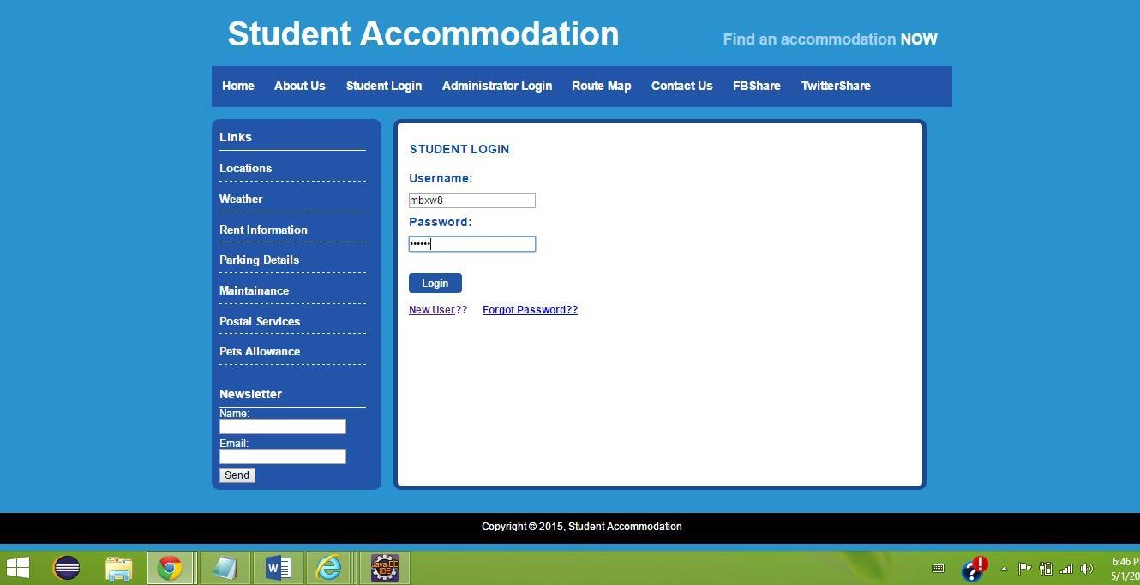

**After entering details into the search field, the user will be provided with a list information related to the search.**

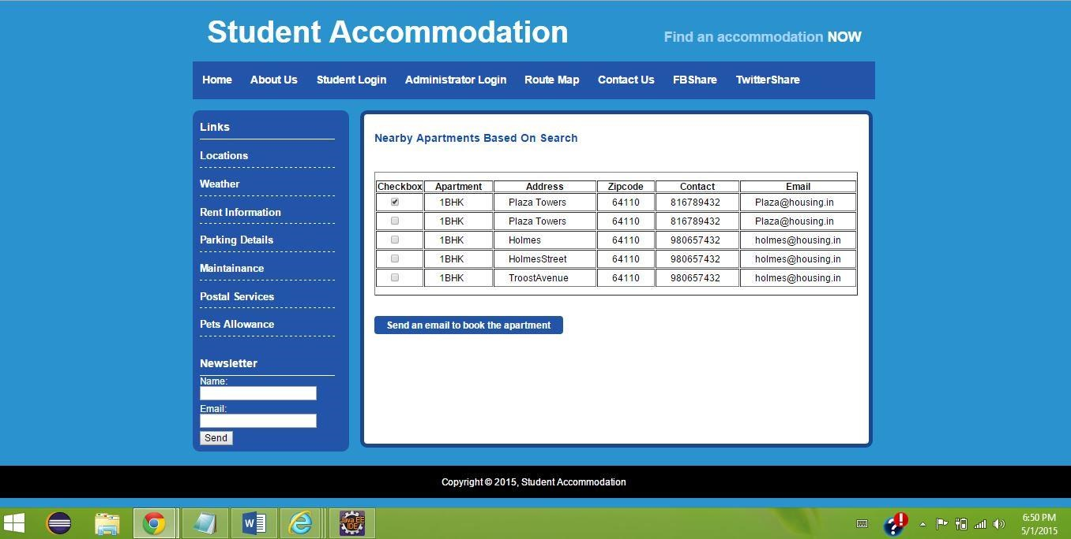

**Administrator is the one who can update the database with newly available vacancies at a particular location.**

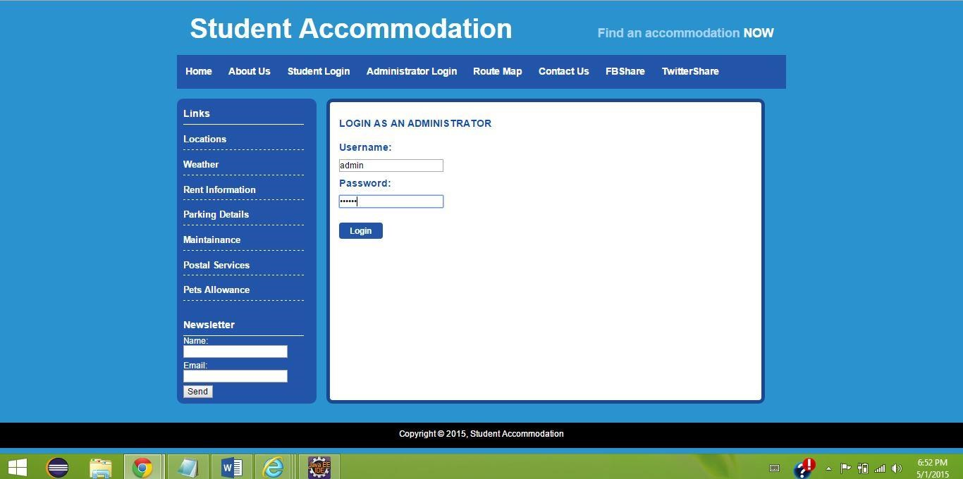

**The administrator can enter the details of newly available vacancy in the following form.**

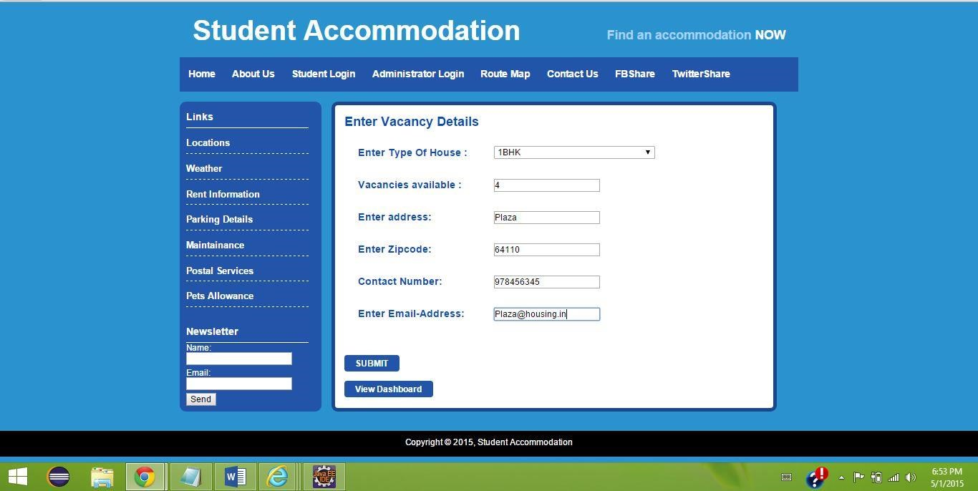

**After successful storage of the vacancies, the administrator will be provided with a pop up message notifying the successful storage.**

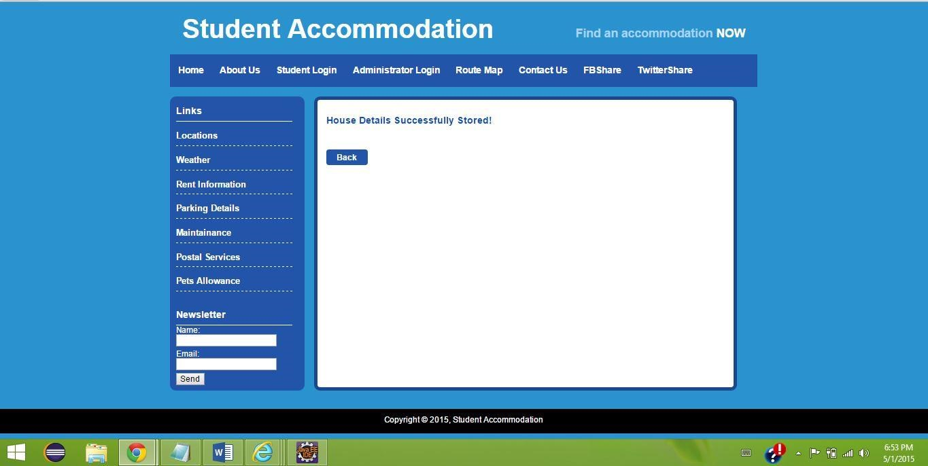

**A dashboard is generated giving the graphical view of the vacancies that are in pending state, reserved and open state.**

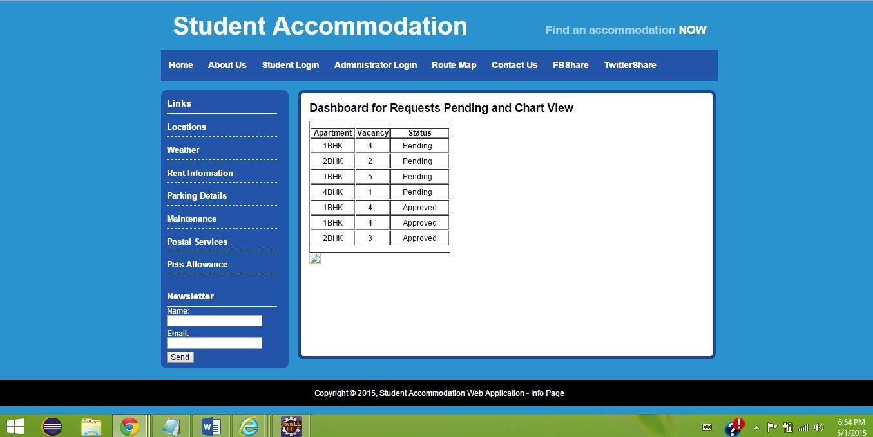

**A google routing map along with the distance matrix algorithm is used to estimate the distance from the university to the desired location.**

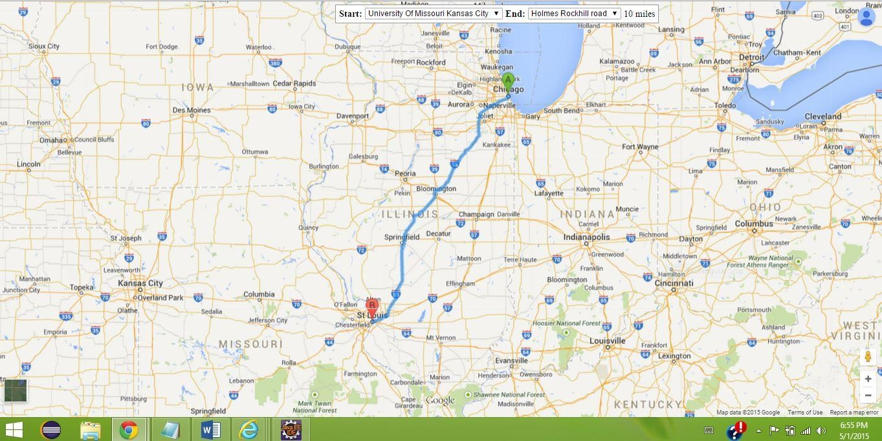

**The student can send an email to the administrator requesting him to reserve a particular vacancy.**

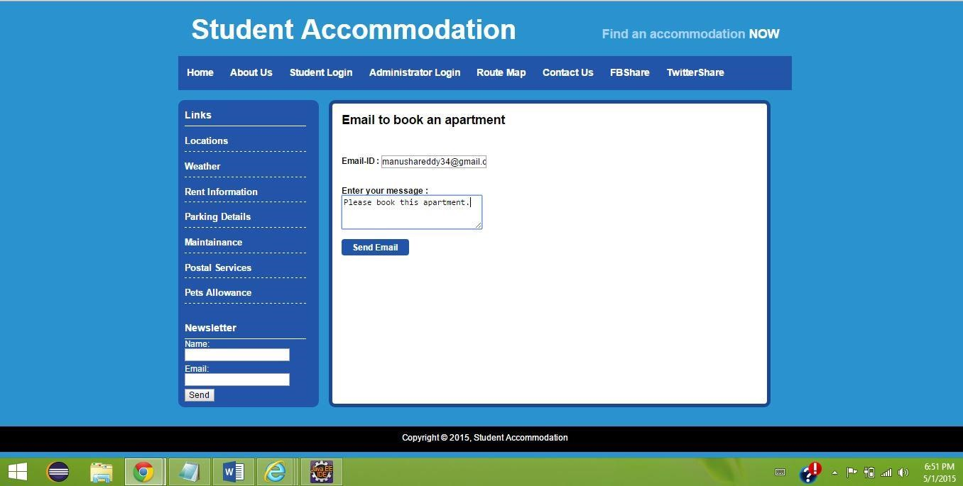

**Two external APIs facebook and twitter are used to share the details of certain vacancy to the friends and other members.**

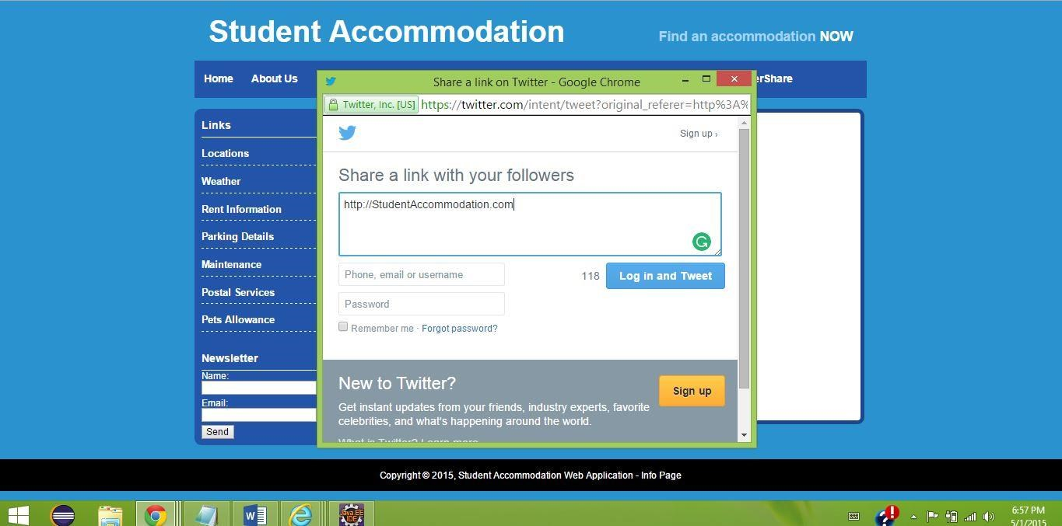

1. **PRESENTATION MATERIAL**
2. **IMPLEMENTATION PACKAGE**

**Project Link**: <https://github.com/snehalagandula/ASE_FinalPG11>

1. **VIDEO FILE**

**Video Link**: <https://www.youtube.com/watch?v=5l6Wc8qDyD0>